1. ------IND- 2005 0140 SI- -EN ------ 20050503 --- --- PROJET

REPUBLIC OF SLOVENIA
MINISTRY OF THE ENVIRONMENT AND SPATIAL PLANNING

TECHNICAL GUIDELINE TSG-1-001:2005

On the basis of Article 11 (1) of the Construction Act (Uradni list RS*, no.102/04 ZGO -1 – UPB and 14/05 – revised) the Minister for the Environment and Spatial Planning hereby issues the technical guideline

FIRE SAFETY IN BUILDINGS

Spread of fire to neighbouring buildings
Load-bearing capacity of construction and spread of fire through buildings
Evacuation routes and detection and alarm systems
Extinguishing apparatus and access for fire fighters

Minister for the Environment and Spatial Planning

...........................................................
(signature)

Number: ..................
Ljubljana, (date) ..............

This technical guideline has obtained:
- the agreement of the Minister for the Economy, number .......... of (date)..................and
- the agreement of the Minister for Defence, number .......... of (date) .......................

This technical guideline is included in the list of technical guidelines of the Ministry of the Environment and Spatial Planning published in the Official Gazette of the Republic of Slovenia, no. …/05 of ………..2005.

Drawings based on originals from Die schweizerischen Brandschutzvorschriften; VKF (Vereinigung Kantonaler Feuerversicherungen) executed by Dr. Stane Srpčič

CONTENTS

0. INTRODUCTION 6
0.1 IMPORTANCE AND ROLE OF THE TECHNICAL GUIDELINE
“FIRE SAFETY IN BUILDINGS” 6
0.1.1 Legal basis for issuing the technical guideline 6
0.1.2 Rules on fire safety in buildings– legal framework for operation of the guideline 6
0.1.3 Legal consequences of using the technical guideline 9

0.2 REFERENCE DOCUMENTS 11
0.2.1 Regulations 11
0.2.2 Standards 12
0.2.3 Guidelines and other documents 13
0.3 MEANING OF TERMS 13

1. SPREAD OF FIRE TO NEIGHBOURING BUILDINGS 14
1.1 INTRODUCTION 14
1.2 MEANING OF TERMS 14
1.3 ESSENTIAL REQUIREMENTS 15
1.4 SPECIAL REQUIREMENTS FOR INDIVIDUAL TYPES OF BUILDING 17
1.4.1 Single dwelling buildings and non-residential farm buildings 17

2. LOAD-BEARING CAPACITY OF CONSTRUCTION AND SPREAD OF FIRE THROUGH BUILDINGS 18
2.1 INTRODUCTION 18
2.2. MEANING OF TERMS 19
2.3 LOAD-BEARING CAPACITY OF CONSTRUCTION 19
2.3.1 Essential requirements 19
2.3.2 Special requirements for individual types of building 21
2.3.2.1 Tall buildings 21
2.4 FIRE COMPARTMENTS 21
2.4.1 Essential requirements 21
2.4.1.1 Requirements for fire resistance of fire compartment separating elements 21
2.4.1.2 Fire protection of mains services and service shafts and their penetrations 25
2.4.1.3 Ventilation ducts 25
2.4.1.4 Smoke and heat vents 28
2.4.1.5 Fire doors 28
2.4.2 Size of fire compartments 28
2.5 SMOKE COMPARTMENTS 29
2.6 SPECIAL REQUIREMENTS FOR INDIVIDUAL TYPES OF BUILDING 29
2.6.1 Single dwelling buildings 29
2.6.2 Apartment buildings 29
2.6.3 Buildings with accommodation rooms 29
2.6.4 Tall buildings 29
2.6.5 Shopping centres 29
2.6.6 Healthcare buildings – hospitals 29
2.6.7 Buildings with atria 29
2.6.8 Buildings with spaces for large numbers of users (e.g. schools, theatres, cinemas, sports halls) 29

3. EVACUATION ROUTES AND DETECTION AND ALARM SYSTEMS 30
3.1 INTRODUCTION 30
3.2. MEANING OF TERMS 30
3.3 EVACUATION ROUTES 30
3.3.1 Essential requirements 30
3.3.2 Determining the number of evacuation routes, their length and width 32
3.3.2.1 Escape route within rooms 32
3.3.2.2 Number of evacuation routes 32
3.3.2.3 Total length of evacuation routes 32
3.3.2.4 Width of evacuation routes 36
3.3.2.5 Below-ground floors 37
3.3.3 Establishing evacuation route 38
3.3.3.1 Protected stairways 38
3.3.3.2 Stairs and ramps 39
3.3.3.3 Corridors 39
3.3.3.4 External fire escapes and walkways 39
3.3.3.5 Doors 39
3.3.3.6 Cladding materials 40
3.3.3.7 Emergency lighting 40
3.3.3.8 Evacuation routes in buildings with sprinkler systems 40
3.3.3.9 Fire lifts 41
3.4 ADDITIONAL REQUIREMENTS FOR BUILDINGS WITH SPACES FOR LARGE GATHERINGS 41
3.4.1 Seats in rows 41
3.5. FIRE DETECTION AND ALARM SYSTEMS 43
3.6 SPECIAL REQUIREMENTS FOR INDIVIDUAL TYPES OF BUILDING 43
3.6.1 Tall buildings 43
3.6.2 Industrial buildings and warehouses 45
3.6.3 Shopping centres 45
3.6.4 Healthcare buildings – hospitals 45
3.6.5 Buildings with atria 45
3.6.6 Buildings with spaces for large numbers of users (e.g. schools, theatres, cinemas, sports halls) 45

4. EXTINGUISHING APPARATUS AND ACCESS FOR FIREFIGHTERS 46
4.1 INTRODUCTION 46
4.2 EXTINGUISHING APPARATUS 46
4.2.1 Water supply for extinguishing 46
4.2.2 Hydrants 47
4.2.2.1 Hydrants on construction parcels 47
4.2.2.2 Internal hydrants 47
4.2.3 Sprinkler systems 47
4.2.4 Special requirements for individual types of building 48
4.2.4.1 Buildings up to 40 m high 48
4.2.4.2 Buildings over 40 m high 48
4.3 UNIMPEDED AND SAFE ACCESS FOR FIREFIGHTERS 48
4.3.1 Unimpeded and safe access for firefighters to buildings 48
4.3.2 Unimpeded and safe access for firefighting and rescue in buildings 48
4.3.3 Smoke and heat venting 48
4.3.3.1 Essential requirements 48
4.3.3.2 Installation of apparatus for smoke and heat venting 49
4.3.3.3 Natural smoke and heat venting 49
4.3.3.4 Forced smoke and heat venting 49
4.3.3.5 Technical requirements for natural and forced venting of smoke 49
4.3.4 Special requirements for individual types of building 49
4.3.4.1 Car park buildings 49
4.3.4.2 Buildings with atria 49
4.3.4.3 Shopping centres 49
4.3.4.4 Healthcare buildings - hospitals 50
4.3.4.5 Buildings with spaces for large numbers of users (e.g. schools, theatres, cinemas, sports halls) 50

5. ADDENDUM 1: FIRE RESISTANCE OF CONSTRUCTION ELEMENTS 51
ADDENDUM 2: CALCULATED NUMBER OF USERS DEPENDING ON PURPOSE OF BUILDING 56 ADDEMDUM 3: QUANTITIES OF WATER NECESSARY FOR INDIVIDUAL TYPES OF BUILDING 57

0. INTRODUCTION
0.1 IMPORTANCE AND ROLE OF THE TECHNICAL GUIDELINE “FIRE SAFETY IN BUILDINGS”
0.1.1 Legal basis for issuing the technical guideline
This technical guideline has been issued by the minister for the environment and spatial planning in agreement with the minister for the economy on the basis of Article 11 (1) of the Construction Act (Uradni list RS, no.102/04 ZGO -1 – officially consolidated text) and the minister for defence, who in accordance with the Fire Protection Act (Uradni list RS, nos. 71/93, 22/01, 87/01 and 110/02 – ZGO-1) has general competence for the area of fire protection, and as such has given his consent to the Rules on fire safety in buildings (Uradni list RS, nos. 31/04 and …), which is the regulation from the minister for the environment and spatial planning that provides the direct legal framework for the functioning of this technical guideline (see point 1.0.2).
In the Construction Act the technical guideline is defined as a “document which for a specific type of structure lays down the detailed definition of essential requirements, design conditions, the selected levels or classes of construction products and materials that may be incorporated and the methods of their incorporation and method of executing construction, with the aim of ensuring reliability of such structure throughout its lifespan, and where appropriate, procedures whereby it shall be possible to determine whether such requirements have been fulfilled” (Article 3 (1) (3.2)).
The legal nature and application of guidelines is addressed in greater detail in Article 9 of the Act, which provides that for individual types of building, construction regulations (a type of implementing regulation issued on the basis of the Act) lay down their technical characteristics such that in view of their purpose these structures fulfil one, several or all of the following essential requirements:
- mechanical resistance and stability,
- fire safety,
- hygiene and health protection and protection of the surrounding environment,
- safe use,
- protection from noise and
- energy saving and heat retention.

The aforementioned provision of the Act further provides that construction regulations may refer to standards or technical guidelines relating to the specific type of structure, and lay down their obligatory use or the assumption that a certain element conforms to the requirements of the construction regulation, if it meets the requirements of standards and technical guidelines. If the construction regulations provide the assumption of conformity, the construction regulations must also define the competent authorities for decision-making and the procedure whereby it is demonstrated that a design which has not used standards or technical guidelines, but rather the designer has used state-of-the-art construction technology systems, ensures at least an equal degree of safety to a design drawn up using standards or technical guidelines.

State-of-the-art construction technology is the level of technology which, at the moment when design documentation is being drafted or construction work executed, represents a specific level of development of the technical capacity of construction products, processes and services based on the recognised findings of science, technology and experience in the field of construction of structures, while at the same time taking account of reasonable costs (Article 3 (1) (3.1) of the Act).

0.1.2 Rules on fire safety in buildings – legal framework for operation of the guideline
The construction regulation providing detailed definition of the essential requirement of “fire safety” for buildings is the Rules on fire safety in buildings. These Rules lay down the following requirements for fire safety:
- spread of fire to neighbouring buildings (Article 3),
- load-bearing capacity of construction and spread of fire through buildings (Article 4),
- evacuation routes and detection and alarm systems (Article 5),
- apparatus for extinguishing and access for fire fighters (Article 6).

The substance of the aforementioned articles is recorded before the introduction to the first to fourth chapters of this technical guideline.
In the chapter of the Rules laying down the method of fulfilling the prescribed requirements, the following provisions are most important for the application of this technical guideline:

Article 7
(issuing and application of technical guidelines)
(1) The minister responsible for spatial and construction affairs shall issue in agreement with the minister responsible for the placing on the market of construction products the following technical guidelines:
- "Spread of fire to neighbouring buildings" (technical guideline addressing the requirements of Article 3 of these Rules),
- "Load-bearing capacity of construction and spread of fire and smoke through buildings" (technical guideline addressing the requirements of Article 4 of these Rules),
- “Evacuation routes and detection and alarm systems” (technical guideline addressing the requirements of Article 5 of these Rules),
- "Apparatus for extinguishing and access for fire fighters" (technical guideline addressing the requirements of Article 6 of these Rules).
(2) If the construction of buildings has incorporated in their entirety the construction measures or systems (hereinafter: measures) set out in the technical guidelines referred to in the preceding paragraph or in documents to which the technical guidelines refer, such construction shall be presumed to conform to the requirements referred to in Articles 3 to 6 of these Rules.

Article 8
(application of other measures)
(1) In place of the measures set out in the technical guidelines referred to in the preceding article, the design and construction of buildings may make use of:
- measures from other standards, technical guidelines, technical specifications, established codes of conduct or other documents providing fire safety measures in the sense of these Rules or
- measures based on calculations within the framework of fire engineering methods.
(2) Measures referred to in the preceding paragraph shall mean use of state-of-the-art construction technology, in accordance with the Construction Act. Fulfilment of the requirement for fire safety pursuant to these Rules shall in such case be ensured in accordance with Article 14 (2) of these Rules.

In the chapter of the Rules setting out the substance of design documentation, the following provisions are most important:

Article 11
(fire safety study, individual plans and building fire safety certificate)
(1) Attainment of the prescribed level of fire safety pursuant to these Rules for complex and highly complex buildings in fire terms referred to in Annex 1 to thes Rules must proceed from a fire safety study made in accordance with fire safety study regulations. The fire safety study shall be a constituent part of the design for obtaining a construction permit.
(2) Attainment of the prescribed level of fire safety pursuant to these Rules for less complex buildings in fire terms referred to in Annex 1 to these Rules must proceed from individual plans as laid down in the regulations on design documentation on the construction of structures. Such plans shall be a constituent part of the execution design.
(3) A summary of the substance of the professional part of the fire safety study or plans referred to in the preceding paragraph relating to fire safety must be set out in the form Building fire safety certificate referred to in Annex 3, which is a constituent part of these Rules. The completed portion of the form “planned measures” shall be an obligatory part of the design documentation for obtaining a construction permit. The column “measures carried out” shall be completed by the responsible designer upon conclusion of the construction. During the period of construction the fire safety study or plans must be available at the construction site for the needs of construction and inspection oversight.
(4) A building fire safety certificate shall be an obligatory attachment as evidence of the reliability of the structure as provided by the Construction Act.

Article 12
(conditions for elaborating fire safety study or individual plans)
(1) A fire safety study referred to in the first paragraph of the preceding article may be made by a responsible designer that fulfils the conditions pursuant to the regulations governing fire safety studies.
(2) Individual plans referred to in the second paragraph of the preceding article may be made by a responsible designer listed in the directory of responsible designers in accordance with the Construction Act who has passed a special or supplementary exam in architecture or technical design.

Article 14
(auditing obligation)
(1) Design documentation relating to highly complex buildings in terms of fire shall require an obligatory audit performed by auditors in accordance with the Construction Act.
(2) An audit shall also be obligatory in the event of a designer referred to in Article 12 (2) of these Rules designing a less complex building in terms of fire with measures from state-of-the-art construction technology in the sense of Article 8 (2) of these Rules. The audit should serve to confirm that the submitted design ensures a level of fire safety at least equal to a design made using the technical guidelines referred to in Article 7 of these Rules.
(3) The provision of the preceding paragraph shall not apply to simple buildings.
(4) If the design of a complex building in terms of fire uses state-of-the-art construction technology measures referred to in Article 8 (2) of these Rules, an audit shall not be obligatory.
(5) If design documentation requires fire safety consent, in respect of fire safety of the building the auditor will generally limit himself to verifying whether the systems in individual parts of the design documentation accord with the fire safety study.

The obligatory content of fire safety studies for the range of structures for which studies are obligatory, and the conditions for persons drawing up studies are set out in the Rules on fire safety studies (Uradni list RS, no. 28/05) and in the Rules on design and technical documentation (Uradni list RS, no. 66/04).

0.1.3 Legal consequences of using the technical guideline

a) Assumption of conformity
As is evident from the previous points of this introduction, the construction measures and systems contained in this technical guideline are simply the recommended manner of fulfilling the requirements on fire safety in buildings prescribed by the Rules. Adherence to the recommended construction measures serves as a basis for establishing the assumption of fulfilling the criteria of the Rules. A responsible designer, who has adhered to the construction measures in this technical guideline in his design, does not need to demonstrate conformity to the relevant regulations during construction and in obtaining the necessary administrative decisions, since such conformity will be automatically assumed on the basis of the provisions of the rules. In this situation the burden of proof regarding non-fulfilment of the requirement of the Rules lies with the competent state authorities.

b) Design using state-of-the-art construction technology
If on the other hand the responsible designer opts to use (in part or in whole) state-of-the-art construction technology measures, as defined by Article 10 of the Rules, the assurance of at least an equal level of fire safety even for less complex buildings in terms of fire must be demonstrated through the obligatory auditing of design documentation, this being the prescribed manner in which the responsible designer demonstrates fulfilment of the prescribed requirement.

c) Relationship with the requirements of regulations in the area of fire safety
The substance of this technical guideline recommends construction measures in the area of fire safety in buildings, which is at the same time the subject of regulation by several regulations and standards. In relation to the valid regulations, this guideline is written in such a way that the proposed construction measures should not be at variance with the requirements of the relevant regulations. If a user of the guideline nevertheless determines that execution of a specific proposed measure would signify a violation of the valid regulations, he must in his work adhere fully to the obligatory requirements of legislation.
Point 0.2.1 takes into account the state of validity of regulations as at the day of publication of this technical guideline. Changes associated with the issuing of new regulations and associated repeals must be monitored by users via the Official Gazette of the Republic of Slovenia or the Official Journal of the European Communities for EC decisions.

d) Reconstruction of buildings
In connection with the reconstruction of buildings, Article 1 (2) of the Rules provides a general restriction regarding use of the Rules, since it is determined that they should be used where the technical possibilities exist to achieve their requirements and the conditions of protection of cultural heritage are observed. This means that at least in certain reconstructions, instead of the measures proposed by this technical guideline, such an alternative combination of preventive or active construction and technical measures must be selected that take into account the specific determined limitations and conditions, and which will contribute to the greatest possible extent to fulfilment of the requirements of the legal order in the area of fire safety. Alternative solutions, be it for the whole building or parts thereof, should be sought. This should be based on the determination that fire protection measures are generally mutually linked, and their final effect cannot be addressed exclusively on the basis of analysing each measure separately, in other words without taking into account the results of the overall selected concept of fire safety.

e) Relationship of the guideline towards organisational measures of fire safety
Although organisational measures of fire safety are not a subject of this technical guideline, nor indeed of the construction regulations to which the guideline is subordinate, it was nevertheless necessary to accommodate them in determining the content of the guideline, since the construction and technical measures proposed in it will ensure the necessary fire safety only on the assumption of appropriately established and permanently followed organisational measures during the use of the building. Only permanently operating active fire safety systems, such as detection and alarm systems, systems for monitoring smoke and heat and for extinguishing, can ensure that the selected fire safety construction measures will indeed play their part and in this way justify the funds invested in them. The same is true of the permanent maintenance of the level during the construction of introduced preventive measures, which are linked to the selection of construction materials and elements (such as cladding, fire doors and fire shutters). Organisational measures whose implementation follows the execution of construction measures are therefore inseparably tied to the latter, and only the combined effect of both will lead to the prescribed and desired high level of fire safety in buildings. For this reason in the item “Reference documents” this technical guideline also sets out regulations governing the area of organisational measures of fire safety.

0.2. REFERENCE DOCUMENTS
0.2.1 Regulations
0.2.1.1 Construction Act (Uradni list RS, no.102/04 ZGO -1 – officially consolidated text),
0.2.1.2 Fire Protection Act (Uradni list RS, nos. 71/93, 87/01),
0.2.1.3. Construction Products Act (Uradni list RS, no. 52/00),
0.2.1.4 Regulation on the introduction and use of a single classification of types of structure and on the determining of structures of national importance (Uradni list RS, no.33/03),
0.2.1.5 Rules on fire safety in buildings (Uradni list RS, no. 31/04),
0.2.1.6 Rules on fire safety studies (Uradni list RS, no. 28/05),
0.2.1.7 Rules on the requirements for ensuring unimpeded access, entry to and use of structures in public use and apartment buildings (Uradni list RS, no. 97/03),
0.2.1.8 Rules on the attestation of conformity and marking of construction products (Uradni list RS, no. 54/01),
0.2.1.9 Rules on the ventilation and air-conditioning of buildings (Uradni list RS, no. 42/02),
0.2.1.10 Rules on the technical regulations for the hydrant network for fire extinguishing (Uradni list SFRJ*, no. 30/91),
0.2.1.11 Rules on the safety of lifts (Uradni list RS, no. 97/03),
0.2.1.12 Rules on design and technical documentation (Uradni list RS, no. 66/04),
0.2.1.13 Rules on fire procedures (Uradni list RS, no. 39/97),
0.2.1.14 Rules on safety signs (Uradni list RS, no. 89/99),
0.2.1.15 Rules on graphical marks for making annexes to fire safety and fire procedure studies (Uradni list RS, no. 138/04),
0.2.1.16 Rules on training employees for fire safety and training persons responsible for carrying out fire safety measures (Uradni list RS, no. 64/95),
0.2.1.17 Rules on the conditions for implementing fire protection (Uradni list RS, no. 64/95),
0.2.1.18 Rules on inspecting and testing installed systems of active fire protection (Uradni list RS, nos. 22/95 and 73/97),
0.2.1.19 Rules on the maintenance of heating apparatus, flues and ventilators in performing the public service of measuring, inspecting and cleaning heating apparatus, flues and ventilators (Uradni list RS, no. 128/04),
0.2.1.20 Regulation on the manner, subject and conditions for performing the obligatory state commercial public service of measuring, inspecting and cleaning heating apparatus, flues and ventilators for the purpose of environmental protection and efficient energy use, protection of human health and protection from fire (Uradni list RS, no. 129/04),
0.2.1.21 Rules on testing hydrant networks (Uradni list RS, no. 22/95),
0.2.1.22 Rules on the minimal technical and other conditions for maintaining manual and portable fire extinguishers (Uradni list RS, no. 108/04),
0.2.1.23 Commission Decision 1996/603/EC, 2000/605/EC and 2003/424/EC establishing the list of products belonging to Classes A (No contribution to fire),
0.2.1.24 Commission Decision 1998/457/EC concerning the test of the Single Burning Item (SBI test),
0.2.1.25 Commission Decision 2000/147/EC and 2003/632/EC implementing Council Directive 89/106/EEC as regards the classification of the resistance to fire performance of construction products,
0.2.1.26 Commission Decision 2000/367/EC and 2003/629/EC implementing Council Directive 89/106/EEC as regards the classification of the resistance to fire performance of construction products, construction works and parts thereof,
0.2.1.27 Commission Decision 2000/553/EC implementing Council Directive 89/106/EEC as regards the external fire performance of roof coverings,
0.2.1.28 Commission Decision 2001/671/EC implementing Council Directive 89/106/EEC as regards the classification of the external fire performance of roofs and roof coverings and
0.2.1.29 Commission Decision 2003/43/EC and 2003/593/EC establishing the classes of reaction-to-fire performance for certain construction products,

0.2.2. Standards
0.2.2.1 SIST ISO 8421-1 Fire Protection - Glossary - Part 1: General terms and phenomena in fires,
0.2.2.2. SIST ISO 8421-2 Fire Protection - Glossary - Part 2: Fire protection of constructions,
0.2.2.3 SIST ISO 8421-3 Fire Protection - Glossary - Part 3: Fire discovery and detection and raising the alarm,
0.2.2.4 SIST ISO 8421-4 Fire Protection - Glossary - Part 4: Apparatus and means for extinguishing fires,
0.2.2.5 SIST ISO 8421-5 Fire Protection - Glossary - Part 5: Smoke control,
0.2.2.6 SIST ISO 8421-6 Fire Protection - Glossary - Part 6: Evacuation and means of escape,
0.2.2.7 SIST ISO 8421-8 Fire Protection - Glossary - Part 8: Terms that are specific for fire extinguishing, emergency services and handling hazardous substances,
0.2.2.8 SIST 1013 Fire Protection - Safety signs - Evacuation route, fire extinguishers and manual fire alarms,
0.2.2.9 SIST EN 1838 Lighting - Emergency lighting,
0.2.2.10 SIST EN 50171 Central power supply systems,
0.2.2.11 SIST EN 60598-2-22 Luminaires - Part 2-22: Particular requirements - Luminaires for emergency lighting,
0.2.2.12 SIST 1007, Indication plates for hydrants,
0.2.2.13 SIST EN 12845, Installed extinguishing apparatus - Automatic sprinkler systems - Design, installation and maintenance,
0.2.2.14 NFPA 13 Standard for the installation of sprinkler systems,
0.2.2.15 NFPA 20 Centrifugal fire pumps,
0.2.2.16 NFPA 20 Water tanks for private fire protection,
0.2.2.17 SIST DIN 4102, Fire performance of construction materials and elements,
0.2.2.18 SIST DIN 14090 Areas for firefighters around buildings - Flächen für die Feuerwehr auf Grundstücken,
0.2.2.19 NFPA 204 Standard for Smoke and Heat Venting,
0.2.2.20 SIST prEN 12101-1 Smoke and heat venting systems - Part 1: Specifications for smoke curtains - requirements and test methods,
0.2.2.21 SIST EN 81-1 - Safety rules for construction and installation of lifts - Part 1: Electric lifts,
0.2.2.22 SIST EN 81-1 A2 - Safety rules for construction and installation of lifts - Part 1: Electric lifts - A2: Drive and pulley rooms,
0.2.2.23 SIST EN 81-1 AC - Safety rules for construction and installation of lifts - Part 1: Electric lifts - Supplement AC,
0.2.2.24 SIST EN 81-28 - Safety rules for construction and installation of lifts - Passenger and goods lifts - Part 28: Alarms in passenger and passenger/goods lifts,
0.2.2.25 SIST EN 81-2 - Safety rules for construction and installation of lifts - Part 2: Hydraulic lifts,
0.2.2.26 SIST EN 81-2 A2 - Safety rules for construction and installation of lifts - Part 2: Hydraulic lifts - A2: Drive and pulley rooms,
0.2.2.27 SIST EN 81-2 AC - Safety rules for construction and installation of lifts - Part 2: Hydraulic lifts - Supplement AC,
0.2.2.28 SIST EN 81-3 - Safety rules for construction and installation of lifts - Part 3: Electric and hydraulic small goods lifts,
0.2.2.29 SIST DIN 18181 Gipskartonplatten im Hochbau; Grundlagen für die Verarbeitung, Gypsum board panels in buildings, basic rules for installation

0.2.3 Guidelines and other documents
0.2.3.1 Guideline TRVB A 126, Brandschutztechnische Kennzahlen verschiedener Nutzungen, Lagerungen und Lagergüter, Technical fire protection characteristic values of various types of facilities, warehouses and stored goods,
0.2.3.2 Die schweizerischen Brandschutzvorschriften; VKF (Vereinigung Kantonaler Feuerversicherungen); Brandschutzerläuterungen; Atriumbauten (Buildings with atria)
0.2.3.3 Guideline VdS 2095, Automatische BMA, Planung und Einbau, Fire detection systems, Guidelines for design and installation,
0.2.3.4 Guideline VdS CEA 4001: Richtlinien für Sprinkleranlagen neu erschienen, Sprinkler systems, design and installation,
0.2.3.5 Smernice Die schweizerischen Brandschutzvorschriften; VKF (Vereinigung Kantonaler Feuerversicherungen); Arbeitshilfen; Parkhäuser und Einstellräume für Motorfahrzeuge (Car park buildings and premises for parking motor vehicles),
0.2.3.6 BVD Brand-Verhuetungs-Dienst fuer Industrie und Gewerbe.

0.3 Meaning of terms
(1) Terms from the area of buildings construction that are not defined in this technical guideline have the meanings as defined in the Construction Act, the Rules on fire safety in buildings and in the standard SIST ISO 6707-1.
(2) Terms from the area of fire safety that are not defined in this technical guideline have the meanings as defined in the Construction Act, the Rules on fire safety in buildings and in the series of standards SIST ISO 8421.
(3) With regard to the meaning of terms defined in individual parts of this technical guideline, see points 1.2, 2.2 and 3.2. The terms defined in these points are valid for the entire technical guideline.
1. SPREAD OF FIRE TO NEIGHBOURING BUILDINGS
Article 3
(spread of fire to neighbouring structures)
(1) External walls and roofs of buildings must be designed and constructed in such a way that by incorporating a gap to the boundary of the construction parcel, the spread of fire to neighbouring parcels is limited.
(2) Dividing walls, together with doors, windows and other penetrations between individual buildings must be designed and constructed in such a way as to limit the spread of fire to neighbouring structures. Two-dwelling buildings and terrace houses shall also be deemed to be individual buildings.

1.1 INTRODUCTION
- The fire performance of external and dividing walls and roofs of buildings is defined by this technical guideline in such a way that, by incorporating a gap to the boundary of the construction parcel, they represent the recommended way of limiting the spread of fire to neighbouring buildings and neighbouring parcels.
- The requirements of this point have been determined according to the principle that a third of the entire energy released in burning is radiated energy.
(3) The requirements of this point do not apply to simple buildings.
(4) The requirements of this point do not apply to those industrial buildings and warehouses used for the storage of hazardous substances and/or in which work with hazardous substances is performed.

1.2 MEANING OF TERMS
(1) The gap from the building is the distance to the boundary of the parcel or to the putative boundary of the parcel.
(2) The putative boundary of the parcel is the boundary at the geometric middle point between two buildings on the parcel(s) of the same owner.
(3) The external wall of the building is that wall of the building and part of the roof (together with doors, windows and other penetrations) which is either parallel to the parcel boundary or putative parcel boundary or which is set at an angle no greater than 80° (see α and β in Figure 1) to the parcel boundary or putative parcel boundary or to the already existing neighbouring building.
(4) A tall building is a building, which, measured from ground level, rises to a height of over 22.0 m at the floor level of the top storey.
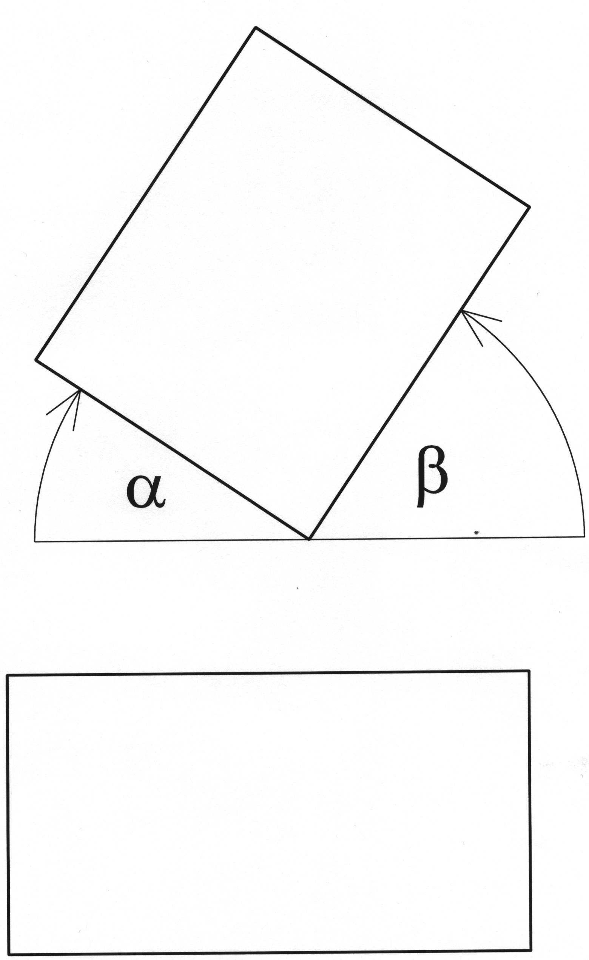

Figure 1: Determining the angle of the external wall relative to the parcel boundary or putative parcel boundary or to the neighbouring building

1.3 ESSENTIAL REQUIREMENTS
- In order to limit the spread of fire, while taking account of the materials selected, the following distances D (m) to the boundary at least must be ensured:

Fire performance of external wall | Required distance D (m)
External wall of each building is of materials in reaction-to-fire class A1 or A2and has a fire resistance of (R)EI 60 (together (R)EI 120); the roof is of A1 or A2 materials, while under the eaves the cladding has a fire resistance of EI 30 [1] | 0 m
External wall is of materials in reaction-to-fire class A1 or A2; the roof is of materials in reaction-to-fire class A1 or A2 | at least 2.5 m
External wall is not of materials in reaction-to-fire class A1 or A2; the roof is not of materials in reaction-to-fire class A1 or A2 | at least 5.0 m

[1] – If the external wall borders on a parcel in public use on which buildings may not be constructed (e.g. road, park) and there is a distance of more than 2.5 m from the external wall of the building to the middle of the parcel in public use, the requirement for fire resistance of the external wall of EI 60 does not apply.

Table 1

ATTENTION!
With regard to construction materials or products for which there are no European standards or European technical approvals (or in the transitional period for already existing European technical specifications), the fire performance of construction materials and products is classified according to the non-harmonised national classifications of individual EU Member States. Determining fulfilment of the requirements of this technical guideline in such cases demands by means of comparative tables a determination (approximately) of the equality of the performance of materials and products used. For the German comparative table see www.dibt.de, for a look at the Austrian comparative table use the Austrian standards ÖNORM B 3806 and ÖNORM B 3807, and for the French comparative table see Legislation et reglementation, Materiaux et elements de construction, Compartement au feu et classification, Les editions des journaux officiels, N° 1540-II.

- There is no restriction on the size of doors, windows and other penetrations in external walls, if the external wall fulfils the requirements of the preceding paragraphs. With regard to restrictions on openings in external façades (curtain walls) in the establishing of evacuation routes, see point 3.3.3.1.
- The gap is measured from the façade of the building, if the projecting roof and/or other parts (balcony, gallery, corridor, conservatory etc) do not extend more than 1.0 m from the surface of the façade. Parts of the building set at a distance of greater than 1.0 m from the façade are a constituent part of the gap (e.g. for a balcony 1.7 m wide, 0.7 m is counted). (see figure 2)

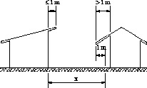

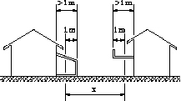

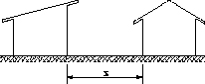

Figure 2: Determining the distance between buildings

The placing of construction products on the market and the significance and role of harmonised technical specifications (European standards and European technical approvals) and the importance and role of national technical specifications is the subject of regulation by the Construction Products Act (Uradni list RS, no. 52/00) and the Rules on the attestation of conformity and marking of construction products (Uradni list RS, no. 54/01).
1.4 SPECIAL REQUIREMENTS FOR INDIVIDUAL TYPES OF BUILDING
1.4.1 Single dwelling buildings and non-residential farm buildings *
(1) In order to limit the spread of fire, while taking account of the materials selected, the following distances D (m) to the boundary at least must be ensured:

Fire performance of external wall | Required distance D (m)
External wall of each building is of materials in reaction-to-fire class A1 or A2and has a fire resistance of EI 60 (together EI 120); the roof is of A1 or A2 reaction-to-fire materials, while under the eaves the cladding has a fire resistance of EI 30 [1] | 0 m
External wall is of materials in reaction-to-fire class A1 or A2; the roof is of materials in reaction-to-fire class A1 or A2 | at least 2.0 m
External wall is not of materials in reaction-to-fire class A1 or A2; the roof is not of materials in reaction-to-fire class A1 or A2 | at least 4.0 m

[1] - If the external wall borders on a parcel in public use on which buildings may not be constructed (e.g. road, park) and there is a distance of more than 2.5 m from the external wall of the building to the middle of the parcel in public use, the requirement for fire resistance of the external wall of EI 60 does not apply

Table 2

2. LOAD-BEARING CAPACITY OF CONSTRUCTION AND SPREAD OF FIRE THROUGH BUILDINGS
Article 4
(load-bearing capacity of construction and spread of fire through buildings)
(1) Buildings must be designed and constructed in such a way that in a fire their load-bearing construction retains the necessary load-bearing capacity for a specific time.
(2) Buildings must be divided into fire compartments if this is essential to limit the rapid spread of fire within them. They must be designed and constructed in such a way that they limit to the greatest possible extent the rapid spread of fire through vertical or horizontal communications. The division into fire compartments and their size depend on:
– the purpose of the building,
– the size and other architectural properties of the individual building,
– the production process operating in the building, and the type and quantity of combustible substances in the building,
– installed or positioned extinguishing systems and
– other fire safety measures carried out.
(3) In order to limit the rapid spread of fire through buildings, such construction materials and construction products must be used that:
– ignite with difficulty,
– in the event of igniting, release low quantities of heat and smoke and
– limit the rapid spread of fire across the surface.

2.1 INTRODUCTION
(1) This point of the technical guideline sets out, as the recommended method of designing, the requirements for the fire performance of the load-bearing construction of buildings, the fire performance of construction elements limiting the rapid spread of fire through buildings and the division of buildings into fire compartments.
(2) The requirements of this point have been determined according to the principle that the load-bearing capacity of the construction and the possible division of buildings into fire compartments, while taking into account the dangers of fire and fire safety measures, will limit for a time the threat to people, animals, property and the environment.
(3) This point does not relate to evacuation routes, which are dealt with in point 3.
(4) In designing and construction, account must be taken in certain cases both of the requirements for fire performance of the load-bearing construction (Table 3) and the requirements for fire performance of fire-separating construction elements of fire compartments (Table 4).
Example 1: The wall may be an element of the building’s load-bearing construction with the requirement for fire resistance R (load-bearing capacity) 60, and may at the same time be a fire-separating construction element with a fire resistance of EI (integrity and insulation) 30 dividing the building into fire compartments.
Example 2: Fire resistance of the fire compartment REI 60 means that the load-bearing construction has a load-bearing capacity of R 60 and that the construction elements dividing the building into fire compartments ensures integrity and insulation of EI 60.

2.2. MEANING OF TERMS
(1) The load-bearing construction is the system of connecting parts that ensures the load-bearing capacity and a specific degree of rigidity for the building (e.g. columns, beams, walls, slabs).
(2) A fire compartment is part of a building comprising one or more rooms constructed in such a way that for a certain period of time the spread of fire from the fire compartment where it started to neighbouring fire compartments is limited.
(3) An atrium is an enclosed space within a building with its own internal façade and which extends through several floors.
(4) A fire cell is a room or group of rooms in a building with a total surface area of up to 200 m² (e.g. an apartment, hotel room, technical spaces) constructed in such a way that for a certain period of time, which may be shorter or longer than in fire compartments, the spread of fire from the fire cell in which it started is limited.
(5) Fire-separating elements are parts of a building that divide the building into several separate fire compartments or fire cells (such as fire wall, fire-resistant ceiling, fire barrier, fire door, fire shutter).
(6) A smoke compartment is a room separated by elements which prevent the spread of smoke.
(7) The fire performance of construction materials, products and elements represents their behaviour in fires, which is divided into reaction to fire and fire resistance.
(8) The fire resistance used in this technical guideline is expressed in minutes: 30, 60 and 90. Fire resistance one level lower means a reduction of 30 minutes.

2.3 LOAD-BEARING CAPACITY OF CONSTRUCTION
2.3.1 Essential requirements
(1) The fire resistance of the load-bearing construction of a building must be determined such that in the event of fire for a certain time the building will retain its stability, as set out in Table 3.
(2) Determining the necessary fire performance of load-bearing construction elements depends on:
- the number of floors,
- specific fire loads *,
- the purpose or risk of fire, and size of building,
- installed extinguishing systems.
(3) Unless otherwise specified by this guideline, the load-bearing construction must be of materials with reaction to fire class of A1 or A2**.
- The requirements of point 2.3 do not apply to single-storey buildings and for the top storey of multi-storey buildings. With regard to the requirements for the top storeys of buildings associated with the establishing of evacuation routes, see point 3.

Number of storeys [1]  Type of building |  | (P+1)  up to 600 m² gross storey area | (P+1)  over 600 m² gross storey area | (P+2) | (P+3) | (P+4)  (P+5)  [2] | (P+6)  (P+7)  [2] | Up to two basement storeys  [3] | More than two basement storeys  [3]
- Residential buildings  - Administrative and office buildings  - School buildings | A  [4] | [5] | R 30  [5] [8] | R 30  [5] [8] | R 60  [5] | R 60 | R 60 | R 60 | R 90
 | B | [5] | [5] | [5] | R 30  [5] [8] | R 60  [5] | R 60 | R 60 | R 90
- Special accommodation buildings e.g. hospitals [6] | A | R 60 | R 60 | R 60 | R 90 | R 90 | R 90 | R 90 | R 90
- Special accommodation buildings e.g. hospitals [6] | B | R 60 | R 60 | R 60 | R 60 | R 60 | R 60 | R 60 | R 90
- Special accommodation buildings, e.g. hotel [7] | A | R 60 | R 60 | R 60 | R 60 | R 60 | R 60 | R 60 | R 90
- Special accommodation buildings, e.g. hotel [7] | B | R 30  [5] [8] | R 30  [5] [8] | R 30  [5] [8] | R 60 | R 60 | R 60 | R 60 | R 90
- Buildings with spaces with large numbers of people  - Shops and sales outlets | A | R 30  [5] [8] | R 30  [5] [8] | R 60 | R 60 | R 60 | R 60 | R 90 | R 90
 | B | [5] | R 30  [5] [8] | R 60 | R 60 | R 60 | R 60 | R 60 | R 90
- Industrial buildings up to 1000 MJ/m² | A | [5] | R 30  [5] [8] | R 30  [5] [8] | R 60  [5] | R 60 | R 60 | R 60 | R 90
- Industrial buildings up to 1000 MJ/m² | B | [5] | [5] | [5] | R 30  [5] | R 60  [5] | R 60 | R 60 | R 90
- Industrial buildings over 1000 MJ/m²  - Other buildings | A | R 30  [5] [8] | R 60 | R 60 | R 90 | R 90 | R 90 | R 90 | R 90
- Industrial buildings over 1000 MJ/m²  - Other buildings | B | [5] | R 30  [5] [8] | R 30  [5] [8] | R 60 | R 60 | R 60 | R 60 | R 90
- Car park buildings  - Premises with vehicles | A | [5] | R 30 [8] | R 30 [8] | R 60 | R 60 | R 60 | R 60 | R 90
- Car park buildings  - Premises with vehicles | B | [5] | [5] | [5] | R 30  [5] [8] | R 60  [3] | R 60 | R 60 | R 90

[1] - landings/galleries of less than 40 % of the gross storey area do not count as storeys;
[2] - where this does not refer to tall buildings;
[3] - the requirement relates only to the bearing construction of basement storeys;
[4] - A – Load-bearing capacity of construction R – if no sprinkler system is installed in the building;
B – Load-bearing capacity R – if a sprinkler system is installed in the building;
[5] - wooden load-bearing construction permitted;
[6] - special accommodation buildings housing patients and persons dependent on the assistance of others or under supervision, such as hospitals, homes for the elderly and for incapacitated, functionally impaired persons, prisons and reform schools of the closed type;
[7] - special accommodation buildings housing persons who as a rule do not require the assistance of others, such as hotels, motels, guest houses and holiday homes;
[8] unprotected steel with a section factor of 35 (m⁻¹) is assumed to have a fire resistance of R 30.

Table 3
2.3.2 Special requirements for individual types of building
2.3.2.1 Tall buildings
(1) The load-bearing construction of tall buildings must have a fire resistance of R 90. The materials used for it must be in reaction-to-fire class A1 or A2.
(2) The requirements do not apply to top storeys.

2.4 FIRE COMPARTMENTS
2.4.1 Essential requirements
(1) The fire resistance of fire-separating elements of fire compartments and their size must be determined in accordance with the requirements of Table 4 and Table 5.
(2) Unless otherwise specified by this guideline, and with the exception of doors and windows, fire-separating elements must in addition to satisfying the requirements of the preceding paragraph be of materials in reaction-to-fire class A1 or A2.
(3) If a sprinkler system is installed in the building, the required fire resistance of the fire-separating elements is reduced in accordance with Table 4.
(4) With regard to the technical requirements for sprinkler systems see point 4.2.3.

2.4.1.1 Requirements for fire resistance of fire-separating elements of fire compartments
(1) The requirements for fire resistance of the load-bearing construction of buildings depend on: the type of building, complexity of the building in terms of fire and fire protection (A, B).
(2) With regard to the assumed fire resistance of fire-separating elements see Addendum 1.

Number of storeys [1]  Type of building |  | (P+1)  up to 600 m² gross storey area  [2] | (P+1)  over 600 m² gross storey area  [2] | (P+2) | (P+3) | (P+4)  (P+5)  [3] | (P+6)  (P+7)  [3] | Up to two basement storeys  [4] | More than two basement storeys  [4]
- Residential buildings  - Administrative and office buildings  - School buildings | A  [5] | EI 30  [6] | EI 30  [6] | EI 30  [6] | EI 60  [6][7] | EI 60 | EI 60 | EI 60 | EI 90
 | B | EI 30  [6] | EI 30  [6] | EI 30  [6] | EI 30 [6][7] | EI 60 [6][7] | EI 60 | EI 60 | EI 90
- Special accommodation buildings e.g. hospitals [8] | A | EI 60 | EI 60 | EI 60 | EI 60 | EI 60 | EI 60 | EI 90 | EI 90
- Special accommodation buildings e.g. hospitals [8] | B | EI 60 | EI 60 | EI 60 | EI 60 | EI 60 | EI 60 | EI 60 | EI 90
- Special accommodation buildings, e.g. hotels | A | EI 30  [6] | EI 60 | EI 60 | EI 60 | EI 60 | EI 60 | EI 60 | EI 90
- Special accommodation buildings, e.g. hotels | B | EI 30  [6] | EI 30 | EI 30 | EI 60 | EI 60 | EI 60 | EI 60 | EI 90
- Buildings with spaces with large numbers of people  - Shops and sales outlets | A | EI 30  [6] | EI 30  [6] | EI 60 | EI 60 | EI 60 | EI 60 | EI 90 | EI 90
 | B | EI 30  [6] | EI 30  [6] | EI 60 | EI 60 | EI 60 | EI 60 | EI 60 | EI 90
- Industrial buildings up to 1000 MJ/m² | A | EI 30  [6] | EI 30  [6] | EI 30  [6] | EI 60 [6][7] | EI 60 | EI 60 | EI 60 | EI 90
- Industrial buildings up to 1000 MJ/m² | B | EI 30  [6] | EI 30  [6] | EI 30  [6] | EI 30  [6][7] | EI 60  [6][7] | EI 60 | EI 60 | EI 90
- Industrial buildings over 1000 MJ/m²  - Other buildings | A | EI 30  [6] | EI 60  [10] | EI 60 | EI 90 | EI 90 | EI 90 | EI 90 | EI 90
- Industrial buildings over 1000 MJ/m²  - Other buildings | B | EI 30  [6] | EI 30  [6] | EI 30  [6] | EI 60 | EI 60 | EI 60 | EI 60 | EI 90
- Car park buildings  - premises with vehicles | A | EI 30  [6] | EI 30  [6] | EI 30  [6] | EI 30 [11]  EI 60 [6][7] | EI 60  EI 30  [11] | EI 60  EI 30  [11] | EI 60 | EI 90
- Car park buildings  - premises with vehicles | B | EI 30  [6] | EI 30  [6] | EI 30  [6] | EI 30  [6][7] | EI 30  [11]  EI 60  [6][7] | EI 60  EI 30  [11] | EI 60 | EI 90

Table 4

[1] - Landings/galleries of less than 40 % of the gross storey area do not count as storeys;
[2] - Applies also to top storeys.
[3] - Where this does not refer to tall buildings;
[4] - The requirement relates only to the fire-separating elements of basement storeys;
[5] - A – Fire performance of fire-separating elements – if no sprinkler system is installed in the building;
B – Fire performance of fire-separating elements – if a sprinkler system is installed in the building;
[6] - wooden fire-separating elements permitted;
[7] - Heat insulation must be in reaction-to-fire class A1 or A2.
[8] - Special accommodation buildings housing patients and persons dependent on the assistance of others or under supervision, such as hospitals, homes for the elderly and for incapacitated, functionally impaired persons, prisons and reform schools of the closed type.
[9] - Special accommodation buildings housing persons who as a rule do not require the assistance of others, such as hotels, motels, guest houses and holiday homes.
[10] - For buildings with a gross storey area of less than 600 m² fire resistance of EI 30 is adequate [6].
[11] - The surface area of permanently open external façade openings is at least 25% of the façade surface area.

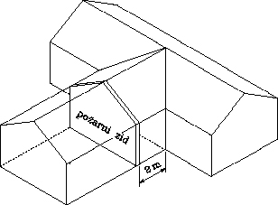fire wall

possible fire wall fire wall

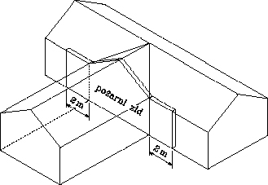fire wall

Figure 3: Separation of fire compartments by fire walls
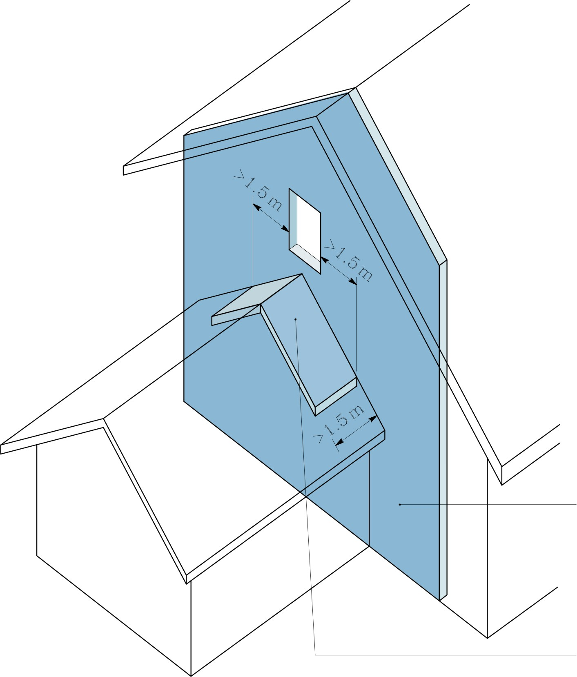
fire-resistant roof
fire wall

Figure 4: Protection of roof and window of two adjoining fire compartments

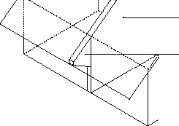
fire wall
fire protection: extended fire wall

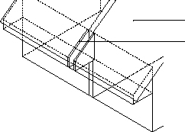
fire wall
fire protection: extended fire wall with cavity reducing the requirements for fire resistance

Figure 5: Separation of fire compartments by fire wall in the attic zone

2.4.1.2 Fire protection of mains services and service shafts and their penetrations
- The fire resistance of the protection of mains service penetrations must be the same as the fire resistance of the construction element which they penetrate.
- Shafts must be functionally separated from each other (e.g. electricity cable shafts from ventilation ducts).
- Service shafts for electricity cables and similar may have a fire resistance one level lower than the requirements for other construction elements of the fire compartment, but no less than EI 30. Maintenance/inspection ports for service shafts must have a fire resistance as follows:
shaft area < 0.5 m² E 30,
shaft area > 0.5 m² EI 30.
- Vertical service shafts must be interrupted by elements with a fire resistance of EI 30 between basement storeys and the ground floor and on every other storey, or at the top of the shaft there must be an opening to the outside of no less than 0.2 m².

2.4.1.3 Ventilation ducts
- In buildings that are not protected by sprinkler systems, built in to the penetrations of ventilation ducts (if their cross-section is greater than 200 cm²) in walls at the separation of fire compartments and fire cells must be fire shutters with a fire resistance that may be one level lower than the required fire resistance for the wall, but no less than EI 30.
- At the penetrations of air conditioning ducts at the separation of fire compartments there is no need to install fire shutters, if the total surface area being ventilated by an individual branch of the ventilation system does not exceed 600 m², even if that surface area covers several fire compartments.
- In fire cells, shutters are installed at the separation of the fire compartment of which they are a part, but in this consideration is given to the requirements from the first and second paragraphs of this point.
- Installation of fire shutters may be omitted if the building has installed an appropriate sprinkler system with a capacity to discharge at least 6 mm/min on a theoretical minimum surface area of 145 m² (this does not apply to buildings containing hazardous substances).
- Installation of fire shutters is not necessary if the adjoining ventilation section is not fed by the same branch of the ventilation ductwork and the duct is protected by cladding with a fire resistance required for the fire compartment.
[legend translation, in order:
Pis.stavba Office building
Enokal. sistem Single-duct system
odvod zraka air vent
zun. zrak outside air
jasek shaft
negorl. kanal non-combustible duct
poz. loputa fire shutter
odvod zraka air vent
jasek (x3) shaft
zun. zrak outside air]
Figure 7: Arrangement of ducts and fire shutters

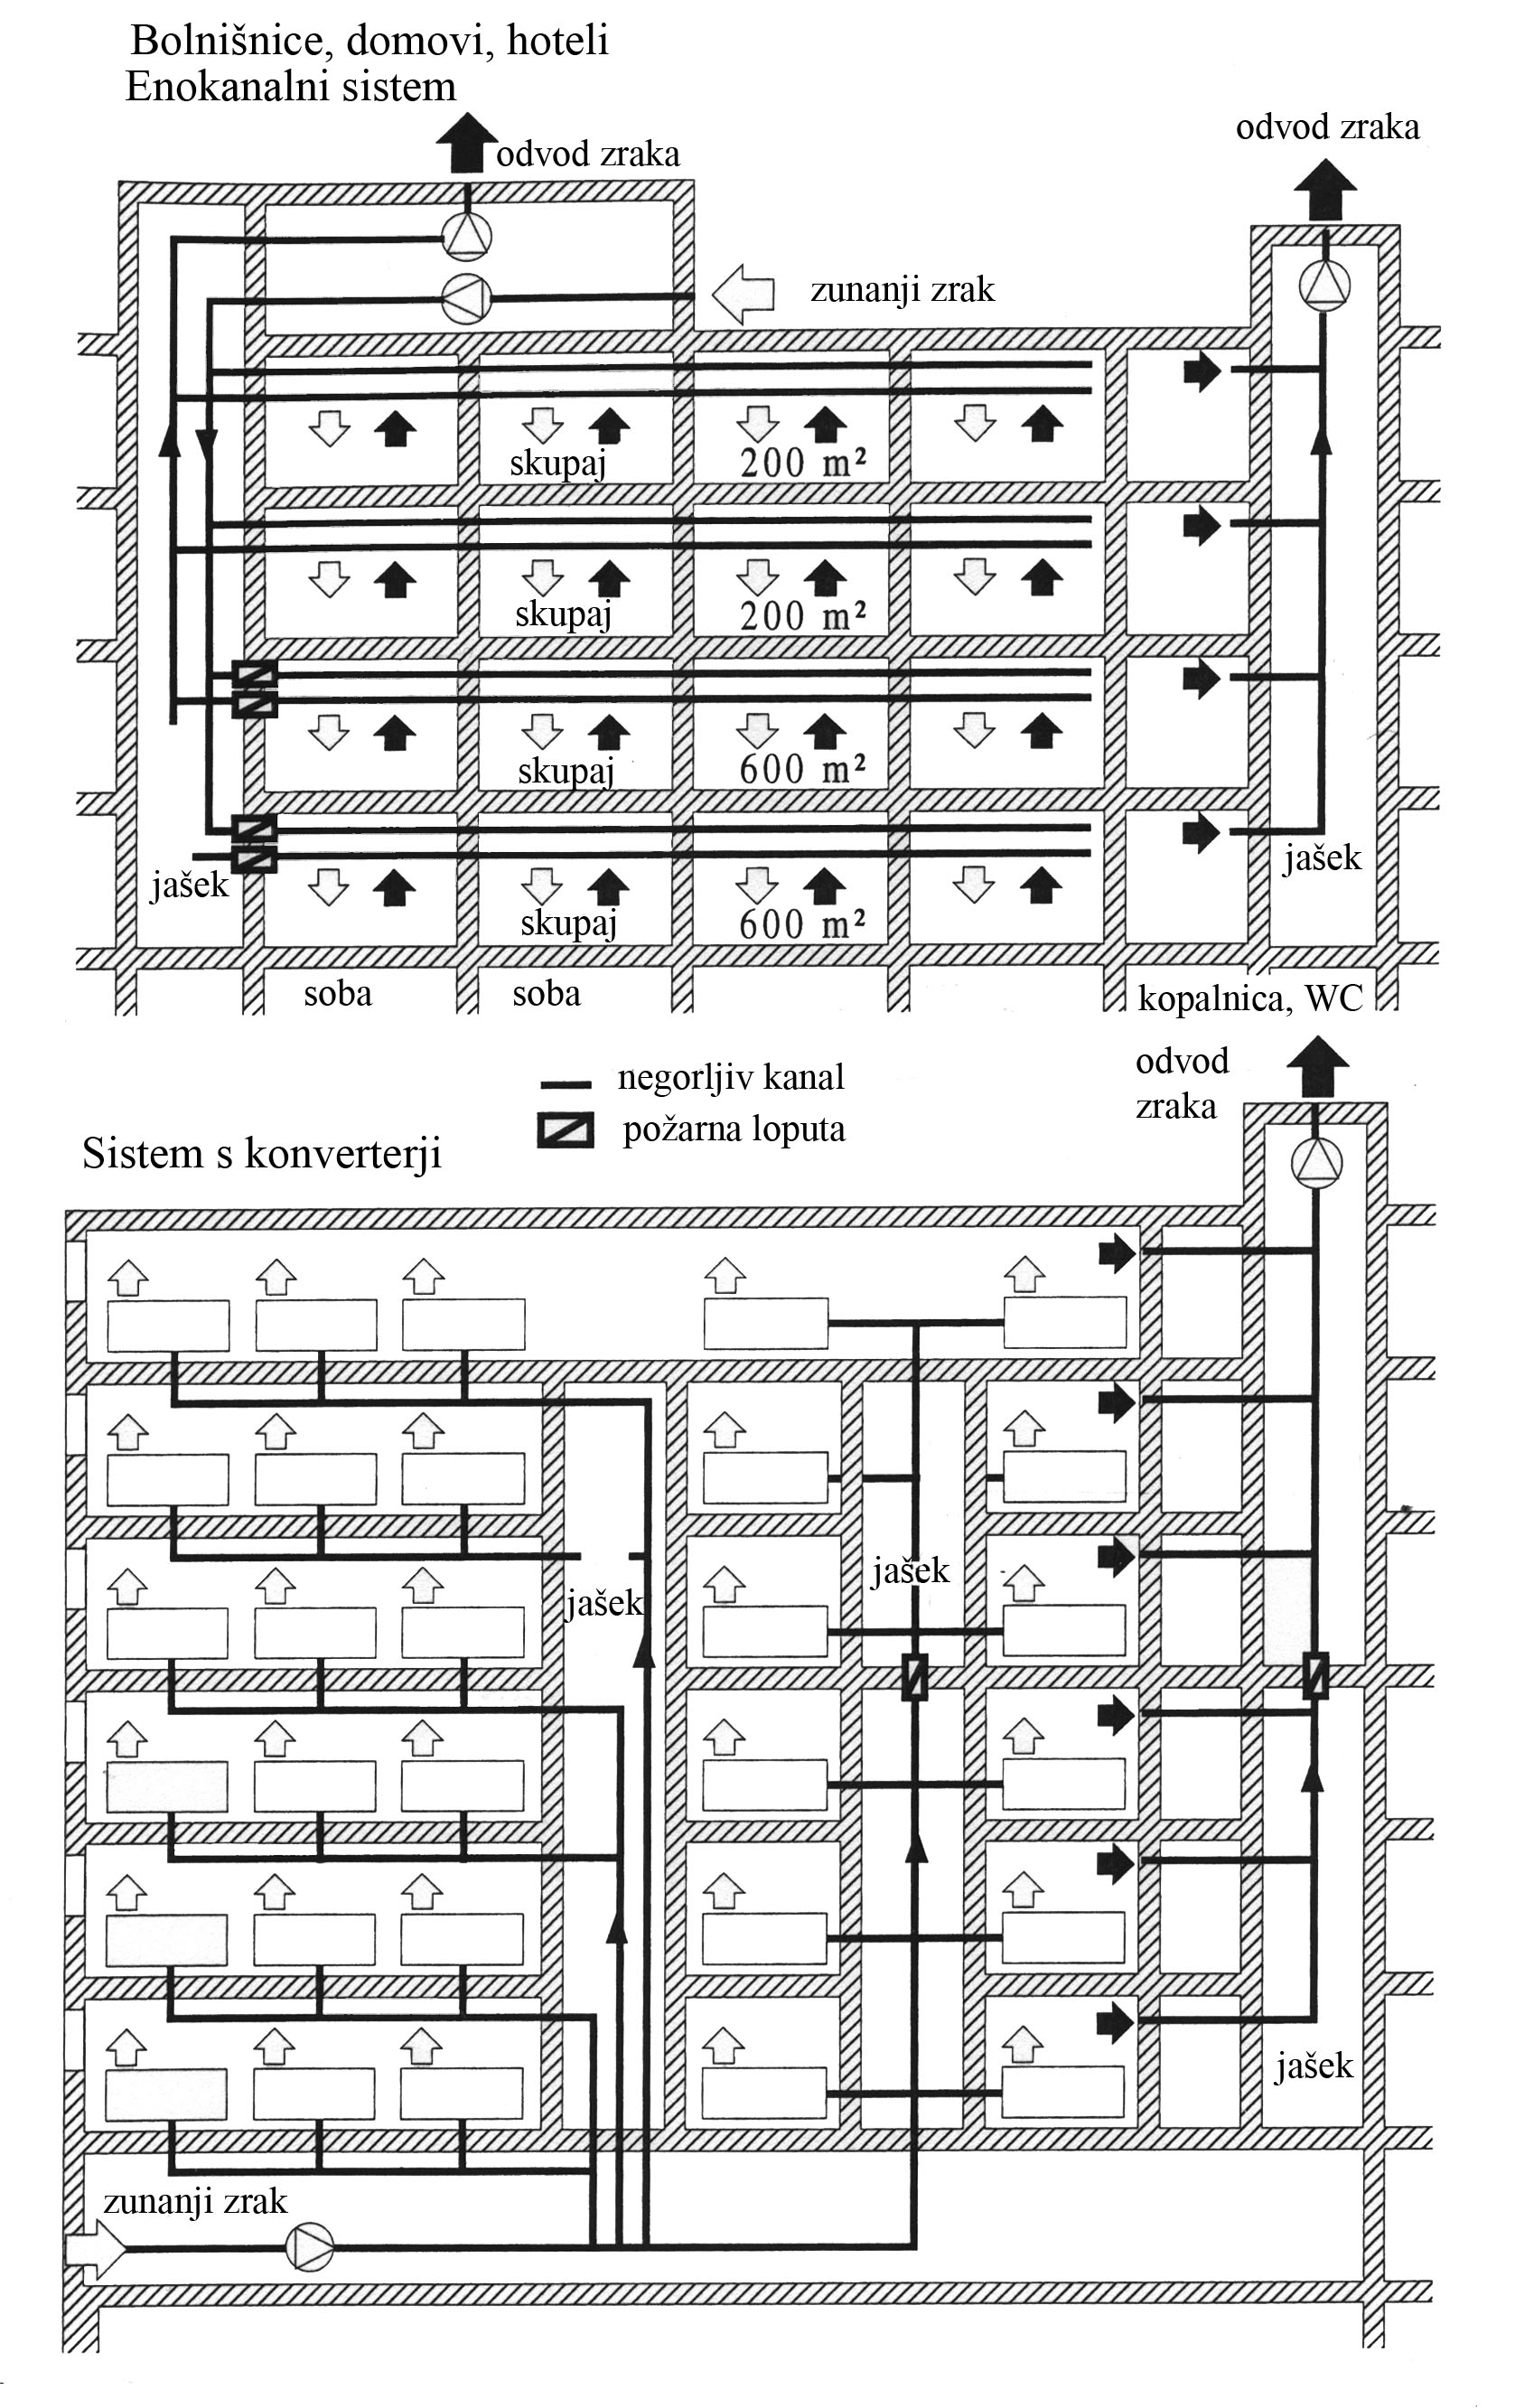
[legend translation, in order:
Boln.., hoteli Hospitals, homes, hotels
Enokan. sist Single-duct system
odvod zraka (x2) air vent
zun. zrak outside air
skupaj (x4) together
jasek (x2) shaft
soba (x2) room
kopalnica, WC washroom, WC
negorl. kanal non-combustible duct
poz. loputa fire shutter
odvod zraka air vent
Sistemi… Systems with converters
jasek (x3) shaft
zun. zrak outside air]

Figure 8: Arrangement of ducts and fire shutters

2.4.1.4 Ducts for venting smoke and heat
- Where they penetrate a fire compartment separation element, ducts for venting smoke and heat must have the same fire resistance as that required for the fire resistance of fire compartment separation or for fire stairs.

2.4.1.5 Fire doors
- Fire doors must be installed at the separation of fire compartments. Fire doors may have a fire resistance one level lower than the wall in which they are installed, but no less than E 30.
- Fire doors must be fitted with self-closing devices.

2.4.2 Size of fire compartments
The maximum permitted sizes of fire compartments are (in m²):

PURPOSE  [1] | WITHOUT ADS OR SPRINKLERS | ADS + smoke and heat vent | SPRINKLERS  [2] [3]
Administrative and office buildings, service buildings | 1200 | 5000 | 8000
Commercial buildings:  Basement  Ground floor  Upper storeys | 1200  2000  1200 | 2000  4000  2000 | 8000  8000  8000
Warehouses: T_{ignit.}<300°C  T_{ignit.}>300°C  HSW | 600  1200  / | 1200  2000  1200 | 8000  8000  8000
Industrial buildings | 2000 | 4000 | 8000
Car park buildings:  basements,  ground floor, upper levels | 1200  1200 | 2500  5000 | 5000  8000

ADS - automatic fire detection and alarm system
HSW - high shelf warehouse is a warehouse where the storage height exceeds 7.5 m
T_{ignit.}- ignition temperature of stored materials

[1] - for other buildings see points 2.6. and 2.7
[2] - see fourth paragraph of point 2.4.1
[3] - standards set out in point 4.2.3 are appropriate
[4] - excluding shopping centres

Table 5

2.5 SMOKE COMPARTMENTS
(1) Smoke compartments within fire compartments are designed according to the standard SIST prEN 12101-1.
(2) Separation of smoke compartments must be ensured through construction elements in reaction-to-fire class A1 or A2.

2.6 SPECIAL REQUIREMENTS FOR INDIVIDUAL TYPES OF BUILDING
2.6.1 Single dwelling buildings
(1) The requirement of the third paragraph of point 2.4.1 does not apply to single dwelling buildings.
2.6.2 Apartment buildings
(1) Each apartment should be a fire compartment with a fire resistance of fire-separating elements of EI 60. There are no requirements in respect of fire resistance for doors to the hallway.
(2) Façade elements between the windows of individual storeys of apartment buildings must ensure fire resistance of EI 30 at a height of 1.0 m.
2.6.3 Buildings with accommodation rooms
(1) Hotel rooms must be executed as fire cells with a fire resistance of separating walls of EI 60. Doors to the hallway must have a fire resistance of E 30 - C.
2.6.4 Tall buildings
(1) Fire-separating elements of fire compartments must have a fire resistance of EI 90.
(2) Penetrations at fire compartment separations must have a fire resistance of EI 60.
(3) Service shaft openings without fire protection may not be located within fire stairways.
2.6.5 Shopping centres
(1) Alongside the requirements of this guideline, design and construction should also incorporate the requirements of VKF, Brandschutzerläuterungen; Verkaufsgeschäfte.
2.6.6 Healthcare buildings - hospitals
(1) To limit the spread of fire through buildings, fire protection measures should be executed by incorporating VKF, Brandschutzerläuterungen; Beherbergungsbetriebe.
2.6.7 Buildings with atria
(1) Alongside the requirements of this guideline, design and construction should also incorporate the requirements of VKF, Brandschutzerläuterungen; Atriumbauten
2.6.8 Buildings with spaces for large numbers of users (e.g. schools, theatres, cinemas, sports halls)
(1) Alongside the requirements of this guideline, design and construction should also incorporate the requirements of VKF, Bauten mit Räumen mit grosser Personenbelegung.

3. EVACUATION ROUTES AND DETECTION AND ALARM SYSTEMS

Article 5
(evacuation routes and detection and alarm systems)
(1) Buildings must be designed and constructed in such a way that in the event of fire there is a sufficient number of stablished evacuation routes and exits at appropriate points, allowing users to leave the building quickly and safely.
(2) Where in view of the design, location, purpose and size of the building it is essential, in order to ensure rapid and safe evacuation of building users and rapid interevntion of the fire service, buildings must be fitted with fire detection and alarm systems.

3.1 INTRODUCTION
- This point of the technical guideline sets out, as the recommended method of designing, the requirements for evacuation routes (requirements for arrangement, construction, technical equipment and maintenance) and detection and alarm systems.
- The requirements of this point have been determined according to the principle that the time needed for withdrawal to a safe place should not last longer than two and a half minutes. Furthermore they are also based on the principle that evacuation routes are used as routes for fire fighting and rescue inside the building.
- This point does not relate to access for fire fighters to buildings, which is dealt with in point 4 of this technical guideline. With regard to venting of smoke and heat in evacuation routes, see point 4.3.3.

3.2. MEANING OF TERMS
(1) Evacuation route is a route along which it is possible to withdraw from any point in the building to the final exit.
(2) A protected part of the evacuation route is that part of an evacuation route provided with an appropriate level of protection from fire.
(3) A safe place is a place to which endangered people can withdraw from the part of a building where there is a fire to be safe; that is: outside, to a protected stairway, and to another fire compartment from which it is possible to withdraw outside.
(4) Safety lighting is a type of emergency lighting which upon the failure of the general lighting system enabling people before they leave to carry out tasks essential for safety, and on leaving to see parts of the evacuation route and signs for exits and the direction of evacuation routes leading to a safe place within or outside the building.
(5) A fire lift is a lift in a fire-safe shaft, in a building or on the façade of a building, with a mechanism, power and controls which in the event of a fire can be operated only by fire fighters.

3.3 EVACUATION ROUTES
3.3.1 Essential requirements
(1) Evacuation routes must be designed in such a way that they represent the shortest possible route for the evacuation of people from a space in danger to a safe place (e.g. to the exit from the endangered space; to the corridor to the stairs and to the outside exit)*.
(2) Evacuation routes must be designed in such a way that they take into consideration above all:
- the type of building, its size and separation into fire compartments,
- the number of storeys,
- the number of users (for the calculation of the number of users in a building see addendum 2) and type of users of the building.
(3) In designing evacuation routes, alongside the requirements of this technical guideline consideration must also be given in particular to the requirements of the Rules on the requirements for ensuring unimpeded access, entry to and use of structures in public use and apartment buildings.
(4) The total length of evacuation routes is added up and is measured in rooms as a straight line, and in corridors on their axis.

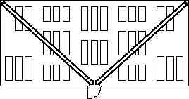

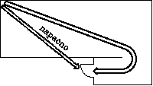

Figure 9: Measuring exit routes within a space

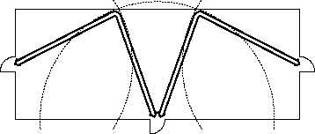

Figure 10: Measuring exit routes within a space with several exits

(5) The length of the route within a protected stairway is not added to the length of the evacuation route.
(6) The width of the evacuation route is measured as:
(a) clearance width of the door,
(b) clearance width of the corridor,
(c) clearance width between stairway banisters,
(d) clearance width between the backrest and the seat in the next row of seats.
(7) Unless otherwise specified by this guideline, in protected parts of evacuation routes materials may be used that are in reaction-to-fire class A1 or A2**.
(8) In places where there are protected parts of evacuation routes (corridors, stairways, exits), roofs must be of materials in a reaction-to-fire class of from A1 to E, but in classes A2 to E they must be further classified as class d0 (no droplets from burning materials).

3.3.2 Determining the number of evacuation routes, their length and width
3.3.2.1 Escape route within rooms
- If a room has just one exit, no point in such room may be further than 20 m from the exit.

- If at least two exits lead from a room, the escape route may not be longer than 35 m. Exits must be spaced to give the greatest possible distance from each other.
- If the single exit does not lead directly outside or to a protected stairway, a protected part of the evacuation route must be arranged.
- Protected stairways may be placed at a maximum distance of 15 m from any corner of the building.
3.3.2.2 Number of evacuation routes
(1) If the gross floor area of the storey (above or below ground) does not exceed 600 m², it is possible for just one evacuation route to lead to the protected stairway. If the evacuation route from the storey leads to several protected stairways, a gross area of the storey per protected stairway of 900 m² is permitted.
3.3.2.3 Total length of evacuation routes
(1) If an evacuation route leads to one protected stairway or one final exit, the total length of the evacuation route may not exceed 35.0 m.
(2) If an evacuation route leads to two or more separate protected stairways or separate final exits, the total length of the evacuation route may not exceed 50.0 m.
(3) Blind corridors may not be longer than 15.0 m.

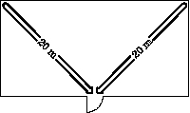
Figure 11: Length of escape route in a room with one exit

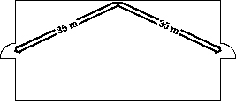

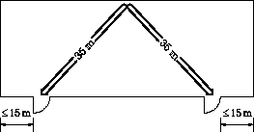

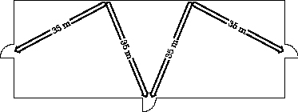

Figure 12: Length of escape route in a room with several exits

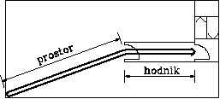[room corridor]

Figure 13: Escape route through room and protected corridor

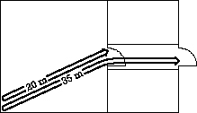

Figure 14: Maximum permitted distance of escape route through room and protected corridor

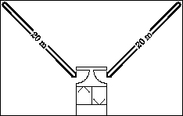

Figure 15: Escape route to protected stairway

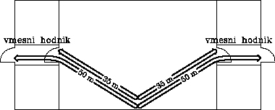[intervening corridor]

Figure 16: Escape route through several corridors

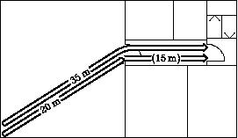

Figure 17: Escape route through protected corridor

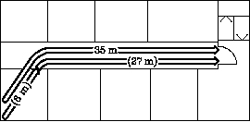

Figure 18: Escape route through protected corridor

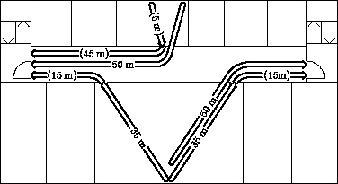

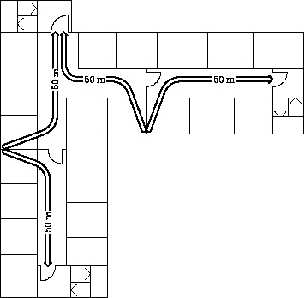

Figure 19: Escape route in several directions

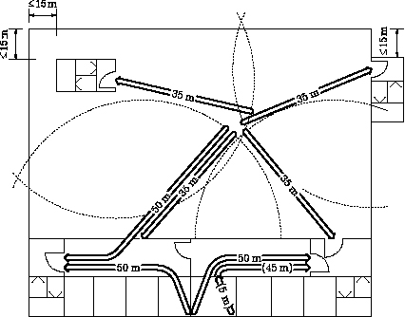

Figure 20: Determining the number and position of escape routes

3.3.2.4 Width of evacuation routes
- The width of exits, corridors and stairways depends on the number of people. Account is taken of the room with the largest number of people (see Figure 21).
- Rooms with large numbers of people must have exits of the following width:
- up to 50 people: one exit 0.9 m wide
- up to 100 people: two exits each 0.9 m wide
- up to 200 people: three exits each 0.9 m wide or two exits, one 0.9 m wide and the other 1.2 m wide
- over 200 people: the total width of all exits is calculated as follows:
i) ground floor: each of 0.6 m per 100 people
ii) upper storeys: each 0.6 m per 60 people
iii) basement storeys: each 0.6 m per 50 people
- If according to calculations the width of exits, stairways and corridors is greater than 1.2 m, each additional width is increased by 0.60 m.
- The minimum width of stairways and corridors must be 1.2 m; the minimum permitted width from residential units is 0.9 m.
- Exits referred to in point d) of the second paragraph must be at least 1.2 m wide. If the necessary width of exits is greater than 1.2 m, the width of exits is increased by 0.6 m (e.g. 1.8 m, 2.4 m), according to the equation:
width of exit = number of people in room * 0.6 m / number of people depending on type of storey

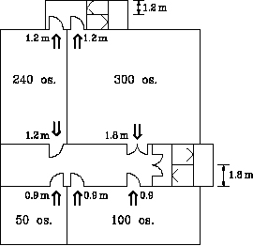[‘os.’ = persons]

Figure 21: Number of exits and stairways and their width relative to the number of people

3.3.2.5 Basement storeys
- The requirements for exits and for protected stairways apply also to basement storeys.
- With two or more basement storeys, two separate stairways are needed.

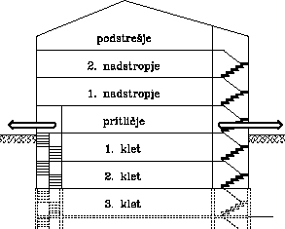

podstr. attic
2./1. nadstr. 2nd / 1st floor
pritl. ground floor
1./2./3/ klet basement level 1/2/3
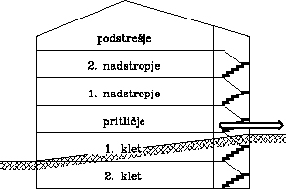
podstr. attic
2./1. nadstr. 2nd/1st floor
pritl. ground floor
1./2. klet basement level 1/2
Figure 22: Stairways in basements
3.3.3 Establishing evacuation routes
3.3.3.1 Protected stairways
- Protected stairways must be fire-separated from the rest of the building. The walls of such stairways must have a fire resistance of (R)EI 60. The fire resistance of penetrations (doors) depends on the purpose and construction of the building. In buildings with low fire load (q < 500 MJ/m²) the fire resistance of penetrations must be E 30, and otherwise EI 30.
- In buildings with a maximum of three above-ground storeys (up to P+2) and for which wooden construction is permitted in point 2.3.1, the necessary fire resistance of protected stairways is REI 60 with materials in reaction-to-fire class A1 or A2.
- External stairways must be arranged in such a way that they are safe from fire within the building, so that in a band 1.5 m around the external stairway the following is ensured:
- the band has a fire resistance of EI 30 and façade cladding is of materials in reaction-to-fire class A1 or A2;
- windows and other openings are beyond the 1.5 m band around the external stairway or they must have glazing with a fire resistance of EI 30;
- accesses from the protected part of the evacuation route to the external stairway are separated by fire doors with a fire resistance of EI 30.
- Exits from external stairways must lead to a safe place.
- A protected stairway in a building in public use which leads to more than one basement storey must have an exit to the outside that is separate from the evacuation route from the above-ground storeys.

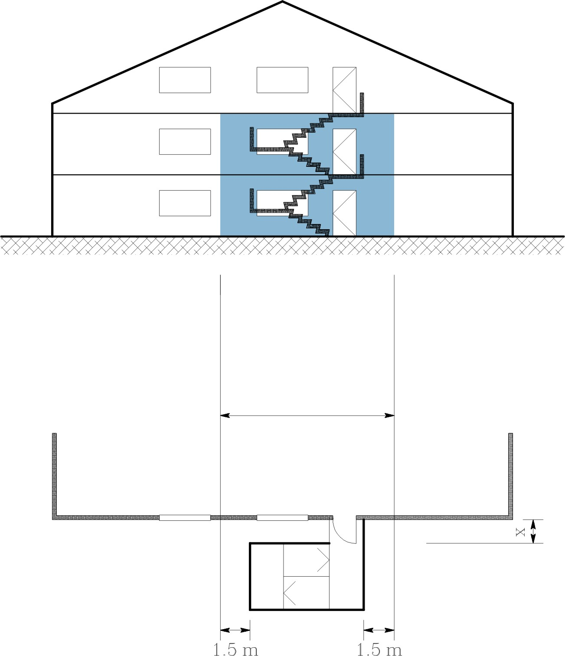
Figure 23: Execution of external stairway
3.3.3.2 Steps and ramps
- Steps and landings must be easily accessible, made from materials in reaction-to-fire class A1 or A2 and straight (not circular, angled etc).
- Circular and angled stairs are permitted for internal communications in apartments and as service access for a maximum of 5 persons.
- Only stairways with at least three steps are permitted in evacuation routes.
- Ramps along evacuation routes may not have an incline over 6 %.

3.3.3.3 Corridors
- Corridors used as a protected part of the evacuation route must be fire-separated from the rest of the building by walls with a fire resistance of EI 30, while penetrations (doors) in such corridors must ensure a fire resistance of E 30, if q < 500 MJ/ m², and otherwise penetrations require a fire resistance of EI 30.
- In buildings where point 2.3.1 permits wooden construction, the following fire performance is required for the protected part of the evacuation route:
- Without sprinkler systems:
- up to P+2: fire resistance of EI 30, wall claddings of materials in reaction-to-fire class A1 or A2,
- P+3: fire resistance of EI 60, wall claddings of materials in reaction-to-fire class A1 or A2 and with a fire resistance of EI 30,
- P+4 and P+5: fire resistance of EI 60, fillings of light partition walls with reaction-to-fire must be at least from 95 ut% class A1 or A2, and claddings on both sides of materials in reaction-to-fire class A1 or A2 and with a fire resistance of EI 30.
- With sprinkler systems:
- up to P+3: fire resistance of EI 30, wall claddings of materials in reaction-to-fire class A1 or A2,
- P+4 and P+5: fire resistance of EI 60, wall claddings of materials in reaction-to-fire class A1 or A2 and with a fire resistance of EI 30,

- Protected parts of evacuation routes must lead to protected stairways. The requirements for fire resistance (walls EI 60; penetrations EI 30; for q < 500 MJ/ m² it is sufficient for penetrations to have E 30) depend on the distance of travel to safety.
- Protected parts of evacuation routes linking protected stairways must be separated from stairways by fire doors of EI 30. The exception is buildings where the fire load in front of the stairway is q < 500 MJ/m², and here the installation of fire doors of E 30 is appropriate.

3.3.3.4 External fire escapes and walkways
- External fire escapes and walkways are permitted where the façade of buildings is of materials in reaction-to-fire class A1 or A2. The floor of external fire escapes and walkways must have a fire resistance of EI 30 and may not have openings.
- External fire escapes and walkways must lead to a safe place or to a protected stairway.
- The external walls of external fire escapes and walkways must have at least 50 % permanently open surface area.

3.3.3.5 Doors
- Doors must open in the direction of escape. The exception to this is doors from rooms:
- with a surface area of no more than 200 m², not intended for the gathering of people
- where there are less than 20 people and
- where there is not a heightened fire risk (e.g. wet areas, engine rooms, heat stations).
- Doors must open without the use of accessories and must be such that the emergency services can open them from the outside.
- Automatic lifting, revolving, sliding and roller doors are permitted only in the event that alongside them there are also doors for persons to use that open in the direction of escape. Another appropriate technical solution is where in the event of interrupted power supply, revolving or sliding doors automatically open, or they can be opened without additional assistance or accessories.
- Doors leading to protected stairways must be fitted with self-closing devices. This requirement does not apply to apartment buildings with less than 10 apartments.
- Doors along evacuation routes in buildings in public use must be fitted with anti-panic handles.

3.3.3.6 Cladding materials
- Wall and ceiling claddings used in the protected part of an evacuation route must be of materials in reaction-to-fire class A1 or A2.
- Floor coverings on the protected parts of evacuation routes must be at least in reaction-to-fire class C_{Fl}.

3.3.3.7 Emergency lighting
- Emergency lighting is obligatory in:
- tall non-residential buildings,
- non-residential buildings in public use,
- special accommodation buildings with more than 30 beds,
- industrial buildings,
- administrative and office buildings with more than 20 work stations.
In tall residential buildings emergency lighting must be provided in protected stairways.
- Exit signs and evacuation route signs must be illuminated by emergency lighting directly or indirectly. Exit signs in rooms for the gathering of people must be illuminated directly.
- Emergency lighting must be executed in compliance with the standards: SIST EN 1838, SIST EN 50171 and SIST EN 60598-2-22.
- Emergency lighting must be assured of electricity supply for at least 1 hour. Back-up electricity supply must come on automatically in 3 seconds.
- In hospitals and other buildings where horizontal evacuation must be ensured, back-up electricity supply must be assured for at least 3 hours, or 1 hour where a generator is installed.

3.3.3.8 Evacuation routes in buildings with sprinkler systems
(1) In buildings with one exit, a sprinkler system does not reduce the requirements for escape routes.
(2) In buildings with more than one exit and with a personal protection sprinkler system installed (RTI < 50 and a discharge rate of at least 6 mm/m² on a theoretical surface area of 145 m²) and with a reliable supply of water of NFPA 20 and NFPA 22 or a dual water supply according to VdS CEA 4001, the following requirements apply to evacuation routes:
- the width of the evacuation route must be at least 1.0 m, and the clearance width of the doors at least 0.8 m;
- if a blind corridor is 1.0 m wide, it may not be longer than 15 m; a blind corridor 1.2 m wide may not be longer than 20 m;
- if escape is possible in two directions, evacuation routes may not be longer than:
- ground floor 90 m
- other storeys 60 m
- ground floor of industrial building 120 m.

3.3.3.9 Fire lifts
- Fire lifts are used for two purposes. They represent part of the evacuation route, and they are also used as part of the route for fire fighting and rescue inside the building (see point 3.1).
- Fire lifts are obligatory in non-residential tall buildings.
- Fire lifts are also obligatory if on storeys above or below ground level there are spaces planned for functionally impaired persons and no other provision has been made for their evacuation in the event of fire. For buildings of up to P+3 it is adequate to provide the possibility of removing functionally impaired persons to a balconies, terraces and walkways that can be reached by fire service ladders.
- Fire lifts must be made in compliance with the Rules on the safety of lifts, and with standards SIST EN 81-1, SIST EN 81-1 A2, SIST EN 81-1 AC, SIST EN 81-28, SIST EN 81-2, SIST EN 81-2 A2, SIST EN 81-2 AC and SIST EN 81-3.

3.4 ADDITIONAL REQUIREMENTS FOR BUILDINGS WITH SPACES FOR LARGE GATHERINGS
- In buildings where at least one room has been designed to hold more than 100 users, irrespective of the gross surface area of the storey (see point 3.3.2.2), at least two stairways must be provided.
- The clearance width of stairways and landings depends on the width of the largest exit from the room with the largest number of people. Stairways with a clearance width of more than 2.4 m must be divided by rails.

3.4.1 Seats in rows
- Seats in rows, intervening spaces between rows and aisles must be arranged to offer the straightest possible escape route.
- The space between rows, including with the seats down, may be no less than 0.45 m. The main aisles between rows must have a clearance width of at least 1.2 m.
- In a single row with access from both ends there may not be more than 32 seats. In a single row with access only from one end, there may not be more than 16 seats.
- Seats must be secured to the floor. If this is not possible, seats in individual rows must be linked to each other so that the passage of persons is not impeded. Only self-folding seats may be installed.
- In enclosed sports halls, stadiums, theatres, cinemas and similar halls, seats must be of materials in reaction-to-fire class C.

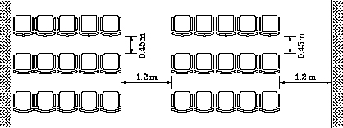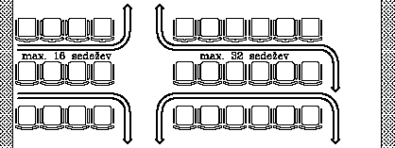

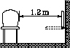

[max. 16 seats max. 32 seats]
Figure 24: Arrangement of seating rows in halls

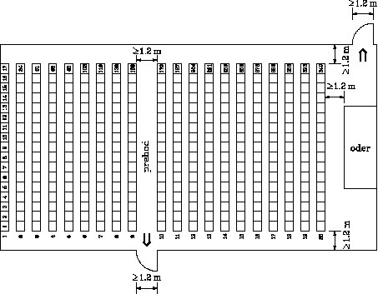

[prehod aisle
oder stage]
Figure 25: Arrangement of seating rows and exits in a ground-floor hall

3.5. FIRE DETECTION AND ALARM SYSTEMS
- Buildings with a fire lift must be equipped with a fire detection and alarm system (ADS), intended to provide partial protection in corridors and stairways making up the evacuation route. In addition to this, ADS must be installed in complex and highly complex buildings in terms of fire which are in public use and which have no sprinkler system installed.
- Installation of an ADS does not reduce the requirements for evacuation routes.
- The entire ADS system must be designed pursuant to guideline VdS 2095.

3.6 SPECIAL REQUIREMENTS FOR INDIVIDUAL TYPES OF BUILDING
3.6.1 Tall buildings
(1) Protected stairways must have a fire resistance of REI 90. One stairway may cover a maximum of 600 m² of gross storey surface area.
(2) Stairways must have one exit to the roof.
(3) Internal protected stairways must have an entrance on each storey leading to an anteroom with fire resistance of EI 90. The doors to anterooms must be fitted with self-closing devices and must have a fire resistance of EI 30. If the cladding on the walls and ceiling of the corridor are in reaction-to-fire class A1 or A2, the doors may have a fire resistance of E 30.
(4) Stairways with external walls may have an entrance through an open anteroom.
(5) Internal protected stairways with anterooms must be mechanically ventilated. Air pressure in the stairway must be 15 Pa higher than in the anteroom.
(6) Ventilation devices must be linked to smoke detectors, which must be activated automatically and manually. Back-up power supply for ventilation devices must be assured for at least 1 hour in compliance with the relevant standard (see third paragraph of point 3.3.3.7)

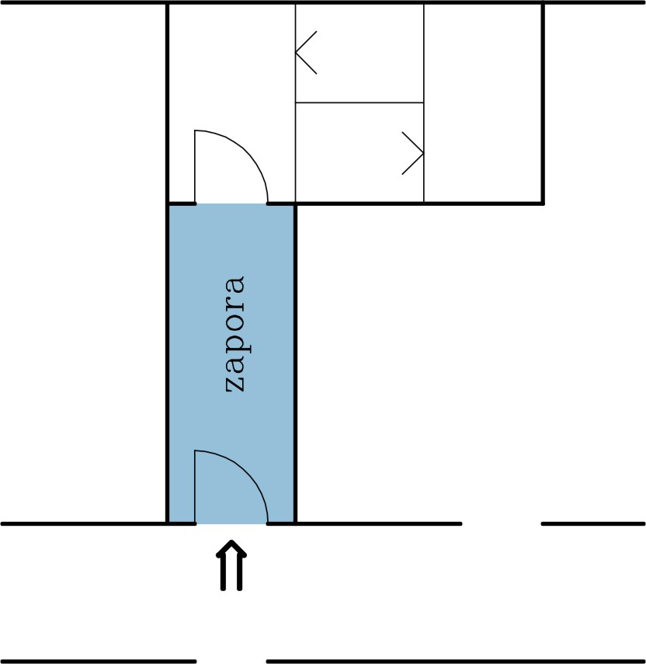

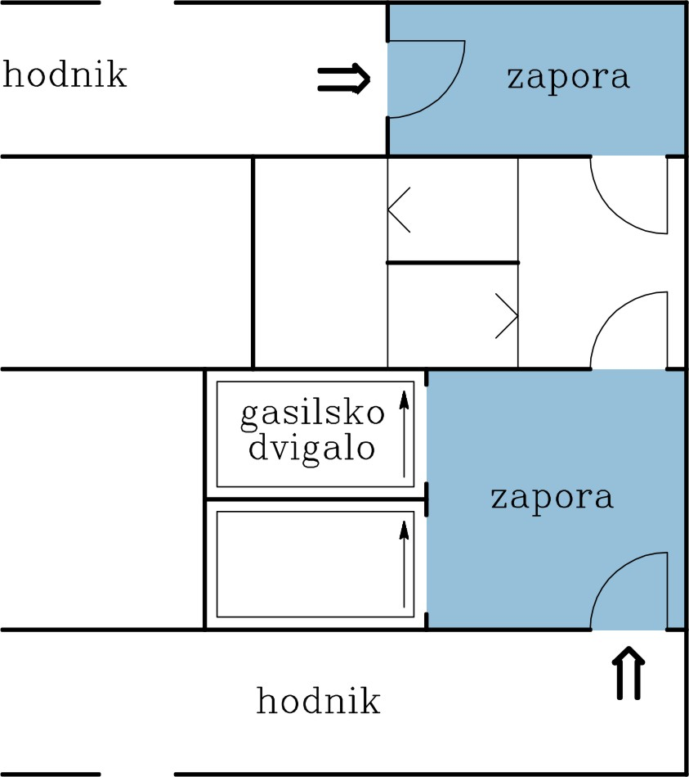

[zapora fire-block anteroom
hodnik corridor
gas. dvigalo fire lift]

Figure 26: Arrangement of stairways in tall buildings with anterooms

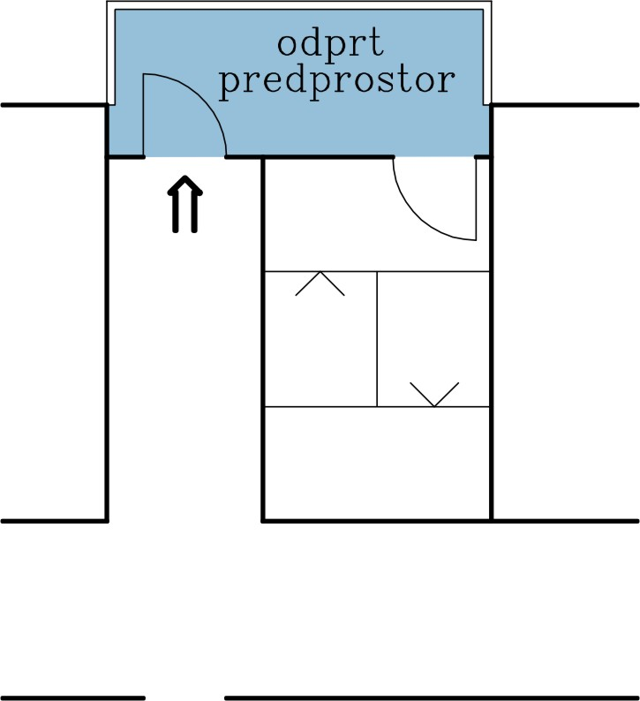

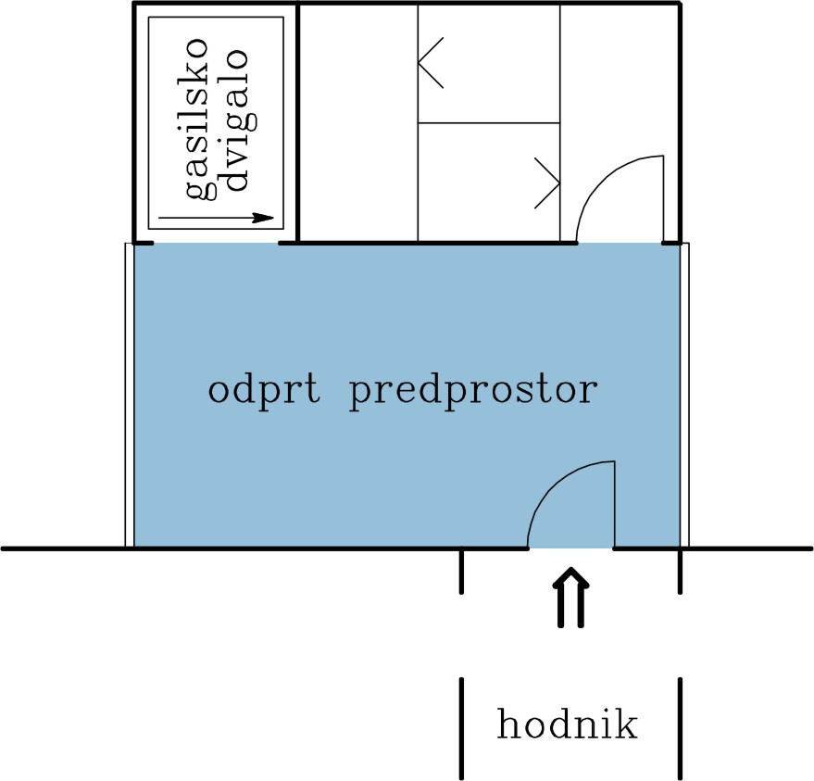
[odprt predpr. open anteroom
gas. dvigalo fire lift
hodnik corridor]

Figure 27: Arrangement of stairways in tall buildings with open anterooms

3.6.2 Industrial buildings and warehouses
(1) In industrial buildings and warehouses with a surface area of more than 1600 m² and/or a large clear height of rooms greater than 7.5 m and where the number of users is less than 50, the number of protected stairways in respect of the requirements from point 3.3.2.2. may be appropriately reduced, if the reduced number of protected stairways still ensures fulfilment of the requirement from Article 5 (1) of the Rules on fire safety in buildings.
(2) Industrial buildings which have a maximum of one basement storey, must in addition to a protected stairway have an arranged evacuation route with emergency exit (suitable ladder) to the level of the surrounding ground.
3.6.3 Shopping centres
(1) In addition to the requirements of this guideline, design and construction should also incorporate the requirements of VKF, Brandschutzerläuterungen; Verkaufsgeschäfte.
3.6.4 Healthcare buildings - hospitals
(1) In order to limit the spread of fire through buildings, fire safety measures should be implemented through the application of VKF, Brandschutzerläuterungen; Beherbergungsbetriebe.
3.6.5 Buildings with atria
(1) In addition to the requirements of this guideline, design and construction should also incorporate the requirements of VKF, Brandschutzerläuterungen; Atriumbauten.
3.6.6 Buildings with spaces for large numbers of users (e.g. schools, theatres, cinemas, sports halls)
(1) In addition to the requirements of this guideline, design and construction should also incorporate the requirements of VKF, Bauten mit Räumen mit grosser Personenbelegung.

4. EXTINGUISHING APPARATUS AND ACCESS FOR FIREFIGHTERS

Article 6
(extinguishing apparatus and access for fire fighters)
(1) Buildings must be designed and constructed such that with regard to the plan, location, purpose and size of the building, in the event of fire:
- there is provision of apparatus and equipment for extinguishing beginning fires which can be used by any user,
- there is provision of apparatus and equipment for extinguishing which can be used by trained users and fire fighters,
- appropriate systems for extinguishing fires are installed.
(2) Unimpeded and safe access must be ensured for fire fighting and rescue in buildings.

4.1 INTRODUCTION
(1) This point of the technical guideline sets out, as the recommended method of designing, the requirements for apparatus, equipment and systems for active fire protection and for ensuring unimpeded and safe access for fire fighting and rescue in buildings.
(2) The requirements of this point have been determined according to the principle that the provided reserve of water for extinguishing will suffice for two hours of extinguishing or for one hour if the building has an installed sprinkler system.
(3) The provision of the public hydrant network, an adequate distribution of hydrants, and flow and water pressure in the mains beyond the boundary of construction parcels on which construction is envisaged do not fall within the remit of construction regulations on fire safety. This area is regulated by the Rules on the technical regulations for the hydrant network for fire extinguishing and by the Rules on testing hydrant networks.
(4) This guideline does not lay down the rules for the placing and use of manual fire extinguishers, which are regulated by the regulation on the selection and placing of fire extinguishers. However an envisaged number and placement of manual extinguishers can be taken into consideration in designing apparatus, equipment and systems dealt with by this technical guideline (see paragraph six of point 4.2.2.2)

4.2 EXTINGUISHING APPARATUS
4.2.1 Supply of water for extinguishing
(1) The water necessary for extinguishing fires in buildings is provided as a rule through the public hydrant network and/or other sources such as:
(a) tanks and reservoirs,
(b) flowing or standing water, if appropriate access for pumping (the pumping height should not be greater than 7.0 m) or pumping stations are available,
(c) fire service vehicles.
(2) In specific cases the size and fire risk of buildings will additionally require the installing of hydrants on the construction parcel itself. Such hydrants are essential for all buildings that:
- Have internal hydrant water,
- are highly complex buildings in terms of fire.
(3) The quantity of water necessary for individual cases is specified in Addendum 3, tables 1 and 2. The quantities of water necessary depend on the fire-complexity of the building and on the installation or otherwise of a sprinkler system.

4.2.2. Hydrants
4.2.2.1 Hydrants on construction parcels
- Hydrants should as a rule be above ground. Permanent access to them must be ensured. Their location is indicated by plates made in compliance with standard SIST 1007. Indication plates for hydrants.
- Hydrants must be connected up to a ring-shaped system of pipes, except in residential buildings, where blind piping up to a maximum length of 200.0 m is permitted.
- The distance between hydrants is determined in such a way that at least one hydrant can be used for fire extinguishing in a building, and at least two hydrants for highly complex buildings in terms of fire. The distance between hydrants may not be greater than 80.0 m, and in residential areas where there are for the most part residential buildings, a maximum of 150 m. The distance between hydrants and buildings may not be less than 5.0 m and greater than 80.0 m.
- The diameter of hydrants must be at least DN 80.
- The speed of water at the junction of the public hydrant network and hydrants on a parcel should not exceed 3.0 m/s.
- The connection and use of fire service pumps should not cause negative pressure and thereby suction from the public hydrant network pipes.

4.2.2.2 Internal hydrants
- Hydrants are obligatory in buildings where the fire compartment is greater than 600 m² and no sprinkler system is installed. Internal hydrants are not obligatory in residential buildings.
- Hydrants may not be located in premises (such as production shops or warehouses) where the use of water might generate inflammable gas, explosions, fire or might in some other way endanger human health and safety.
- Hydrants must be wet, with semi-rigid hose piping. Hydrants must be positioned on each storey such that it is possible to cover the entire surface of the storey with one jet.
- The diameter of the hydrant output pipe depends on the fire load of the building:
- up to 1000 MJ/m²; DN 20
- over 1000 MJ/m²; DN 37
- Hydrants referred to in indent (i) of the preceding paragraph are intended for all users of the building, while hydrants in indent (ii) are only for trained users of the building and fire fighters. Hydrants in indent (ii) must be appropriately protected and furnished with the caution “only for trained persons and fire fighters”.

4.2.3 Sprinkler systems
(1) Sprinkler systems must be executed in compliance with standard SIST EN 12845 or designed and installed in compliance with VdS CEA 4001 or designed and installed in compliance with standards NFPA 13, NFPA 20 and NFPA 22.
(2) With regard to the effect of a sprinkler system on other fire safety measures, see points 2.3.1, 2.4.1, 2.4.2, 3.3.3.3, 3.3.3.8, 3.5, 4.2.1 and 4.3.3.2.

4.2.4 Special requirements for individual types of building
4.2.4.1 Buildings up to 40 m high
- There should be a dry riser main, accessible only to the fire service (signs, key).
- The connection for the fire service (a C clamp is appropriate) must be marked and always accessible.
4.2.4.2 Buildings over 40 m high
(1) A water tank must be provided on the level of the top storey. The quantity of water necessary is calculated in relation to the biggest fire compartment.

4.3 UNIMPEDED AND SAFE ACCESS FOR FIREFIGHTERS
4.3.1 Unimpeded and safe access for fire fighters to buildings
- Vehicle and personnel access and operations surfaces are regulated in compliance with standard SIST DIN 14090.
- For buildings with a ground surface area of up to 600 m² foot access must be ensured, while for buildings with a surface area of from 600 m² to 6000 m² and length to width ratio of the ground plan of at least3:1, access to at least one side of the building and at least one operations surface for emergency services must be ensured. For buildings with a ground surface area of over 8000 m² access must be ensured to at least two sides of the building and at least two operations surfaces for emergency services, and these must be arranged on different sides of the building.

4.3.2 Unimpeded and safe access for fire fighting and rescue in buildings
- Emergency services routes (for fire fighting and rescue in buildings) run along evacuation routes. The approach selected is based on the principle that fire fighters will use emergency service routes only when the evacuation of building users is completed. With regard to the requirements for evacuation routes and fire lifts, see point 3.

4.3.3 Smoke and heat venting
4.3.3.1 Essential requirements
- The extraction of smoke and heat ensures the protection of people (enabling safe evacuation and safe emergency intervention) and the protection of property (reducing the heat stress on the construction of the building and the damage caused by hot smoke gases and the products of burning on furnishings and equipment).
(2) Smoke venting from protected stairways must be provided in buildings used by large numbers of people (such as hotels and other hospitality buildings, shops, offices and schools) and if their stairways connect more than three storeys.
(3) Smoke venting from protected stairways must be provided where they connect more than four above-ground storeys.
(4) Where the manual opening of exterior wall openings on protected stairways is not possible, the top of the stairway must have an opening for smoke venting 5 % of the size of its ground plan surface area, with the aerodynamic surface amounting to at least 0.5 m².
(5) The opening of smoke vent openings that are not on the exterior wall must be made possible on the ground floor. Opening must also be ensured in the event of power failure.
(6) In tall buildings with one protected stairway linking four or more storeys, there must be a positive pressure of 15 Pa in the stairway such that in case of fire the intrusion of smoke into the stairway is prevented. The same applies for protected stairways whose width, owing to the number of people, is at least 3.6 m.
(7) Smoke and heat venting may be provided naturally (rising chimney effect) or through the forced extraction of smoke (by means of ventilators).
(8) With regard to smoke venting see also the requirements of the Rules on the ventilation and air-conditioning of buildings.

4.3.3.2 Installation of apparatus for smoke and heat venting
- Apparatus for smoke and heat venting must be installed in single storey (ground floor) buildings with a large surface area (surface area equal to or greater than 1600 m²).
- Exceptions where there is no need to install smoke and heat venting apparatus:
- in buildings with sprinkler systems or buildings protected by automatic extinguishing systems using gases, mixtures of gases or light foam.
- in buildings there is the probability of the slow start of fires,
- in warehouses with high ceilings and large volume.

4.3.3.3. Natural smoke and heat venting
- In spaces with a clear height of at least 4 m, natural smoke and heat venting is adequate. Vent openings must have an aerodynamic surface amounting to 5 % of the gross floor surface area of the space.
- Inlet vents without any calculation must have an aerodynamic surface amounting to 5 % of the gross floor surface area of the space.

4.3.3.4 Forced smoke and heat venting
- In spaces with a clear height of up to 4.0 m the forced extraction of smoke must be ensured. The capacity of the smoke vent must suffice to change the air 15 times per hour. Extraction ventilators must be in the class 1 h / 400° C.
- In designing the capacity of forced smoke venting, account may betaken of the operation of the sprinkler system pursuant to standard NFPA 204.
- Inlet vents must have a surface area that does not allow the speed of fresh air to exceed 3 m/s.

4.3.3.5 Technical requirements for natural and forced venting of smoke
- Smoke and heat venting should be executed in compliance with standard SIST prEN 12101-1.

4.3.4. SPECIAL REQUIREMENTS FOR INDIVIDUAL TYPES OF BUILDING
4.3.4.1 Car park buildings
(1) Smoke and heat venting in car park buildings should be executed in compliance with VKF Arbeitshilfen, Parkhäuser und Einstellräume für Motorfahrzeuge (Car park buildings and premises for parking motor vehicles).

4.3.4.2 Buildings with atria
- Smoke and heat venting in buildings with atria should be executed in compliance with VKF, Brandschutz-erläuterungen; Atriumbauten.
4.3.4.3 Shopping centres
(1) Alongside the requirements of this guideline, design and construction should also incorporate the requirements of VKF, Brandschutzerläuterungen; Verkaufsgeschäfte.

4.3.4.4 Healthcare buildings - hospitals
(1) To limit the spread of fire through buildings, fire protection measures should be executed by incorporating VKF, Brandschutzerläuterungen; Beherbergungsbetriebe.
4.3.4.5 Buildings with spaces for large numbers of users (e.g. schools, theatres, cinemas, sports halls)
(1) Alongside the requirements of this guideline, design and construction should also incorporate the requirements of VKF, Bauten mit Räumen mit grosser Personenbelegung.
Addendum 1
FIRE RESISTANCE OF CONSTRUCTION ELEMENTS

This addendum sets out the fire resistance of some of the most frequently used construction elements. The data on fire resistance are based on tests performed. For additional data and other construction elements see BVD Brand-Verhuetungs-Dienst fuer Industrie und Gewerbe, or SIST DIN 4102.

- Load-bearing parts of building construction without a fire-separating function
- Load-bearing parts of building construction with a fire-separating function
- Non-load-bearing parts of building construction with a fire-separating function
- Systems for fire protection of load-bearing construction elements
- Systems for ventilation and smoke and heat venting

1. Load-bearing parts of building construction without a fire-separating function:

1.1 Reinforced concrete columns

Column | Multilateral fire load | R 30 | R 60 | R 90
 |  | d | d | d
 | Minimum cross section (mm) | 150/150 | 200/200 | 240/240

Table 1: Minimum cross section of reinforced concrete columns for varying fire resistance under multilateral fire load

1.2. Reinforced concrete beams

Beam | Multilateral fire load | R 30 |  | R 60 |  | R 90
 |  | d (mm) | u (mm) | d (mm) | u (mm) | d (mm) | u (mm)
 | Minimum cross section (mm) | 200/200 | 20 | 300/300 | 35 | 400/400 | 45

Table 2: Minimum cross section of reinforced concrete columns (d) for varying fire resistance under multilateral fire load and minimum axial shifting of reinforcement (u)

1.3 Wooden beams

Taking into account the minimum width of wooden beams set out in table 3, we may assume that their load-bearing capacity in case of fire is R 30. The table applies to beams from cut conifer timber under quadrilateral fire load.

 | Length of beam (m)
Height/width ratio | 2.0 | 3.0 | 4.0 | 5.0 | 6.0
1.0 | 187 | 204 | 219 | 229 | 237
2.0 | 161 | 179 | 193 | 202 | 204

Table 3: Minimum width of beams (mm) from cut timber for fire resistance of R 30

Taking into account the minimum width of wooden beams set out in table 4, we may assume that their fire resistance is R 30. The table applies to beams of glued conifer timber under quadrilateral fire load.

 | Length of beam (m)
Height/width ratio | 2.0 | 3.0 | 4.0 | 5.0 | 6.0
1.0 | 169 | 188 | 202 | 202 | 202
2.0 | 147 | 167 | 168 | 168 | 168
4.0 | 139 | 157 | 157 | 157 | 157
6.0 | 136 | 154 | 154 | 154 | 154

Table 2: Minimum width of beams (mm) of glued conifer timber with fire resistance of R 30.

Taking into account the minimum width of wooden beams set out in table 3, we may assume that their fire resistance is R 60. The table applies to beams of glued conifer timber under quadrilateral fire load.

 | Length of beam (m)
H/w ratio | 2.0 | 3.0 | 4.0 | 5.0 | 6.0
1.0 | 269 | 296 | 320 | 342 | 362
2.0 | 228 | 257 | 283 | 305 | 323
4.0 | 213 | 242 | 268 | 290 | 306
6.0 | 209 | 238 | 264 | 285 | 300

Table 3: Minimum width of beams (mm) of glued conifer timber with fire resistance of R 60.

2. Load-bearing parts of building construction with a fire-separating function:

2.1. Reinforced concrete walls and ceilings.

 |  | REI 30 |  | REI 60 |  | REI 90
 | type of construction element | d (mm) | u | d (mm) | u | d (mm) | u
CEILING | RC panels without coating | 80 |  | 80 |  | 100
 | RC panels with coating:
 | thickness of panels | 50 |  | 50 |  | 50
 | total thickness of panels and coating | 80 |  | 80 |  | 100
 | RC panels with floating coating:
 | thickness of panels | 80 |  | 80 |  | 80
 | thickness of coating | 25 |  |  |  | 25
 | axial shift of reinforcement (mm) |  | 10 |  | 25 |  | 35
WALL
 | load-bearing wall | 120 | 10 | 130 | 10 | 140 | 25

Table 4: Minimum thickness of reinforced concrete (RC) panels and walls (d) for varying fire resistance and minimum axial shift of reinforcement (u)

2.2. Brick walls

 | EI 30 | EI 60 | EI 90
Brick walls | 115 | 115 | 175

Table 5: Minimum thickness of brick walls for varying fire resistance

3. Non-load-bearing parts of building construction with a fire-separating function:

3.1. Non-load-bearing partition walls of various construction materials.

 | EI 30 | EI 60 | EI 90
Brick walls | 115 | 115 | 115
Reinforced concrete | 80 | 90 | 100
Cellular concrete | 75 | 75 | 100
Silicate panels | 18 | 30 | 40

Table 6: Minimum thickness of non-load-bearing walls of various construction materials for varying fire resistance.

3.2. Light partition walls of GKF gypsum fibre board on load-bearing sections of sheet metal sections and intervening insulation with a melting point of above 1000 ºC. The panel thicknesses indicated are bolted from every side of the supporting construction. In the application of several layers the clasps for the lower layers of panels must also be puttied. Clasps must be staggered relative to the previous layer.

 | EI 30 | EI 60 | EI 90
Gypsum fibre board (GKF): | 12.5 mm | 2 x 12.5 mm | 15 mm + 12.5 mm
Intervening insulation layer 40 mm thick. Melting point above 1000 ºC. Volume mass of at least: | 30 kg/m³ | 40 kg/m³ | 40 kg/m³

Table 7: Minimum thickness of non-load-bearing walls of GKF gypsum fibre board for varying fire resistance.

4. Systems for fire protection of load-bearing construction elements

Once they exceed the limit of their plasticity, steel load-bearing construction elements lose their role as load-bearing construction elements. Exceeding the limit of plasticity depends on the factor of the section, which is expressed as the relationship between the internal extent of the fire protection cladding and the cross section of the steel load-bearing construction element.

4.1. Silicate panels

Where the factor of the section (m⁻¹) and the thickness of silicate panels accord with the table, we may assume that the fire resistance of the steel construction is equal to the indications in the table. Silicate panels are fixed to each other with steel clasps or bolts. In protecting beams, however, strips of silicate panel are placed under the clasps. The table applies to the protection of columns and beams.

Thickness of panels (mm) | R30 | R60 | R90
12 | ≤300 | ≤ 125 | ≤ 65
15 |  | ≤ 190 | ≤ 90
18 |  | ≤ 250 | ≤ 110
20 |  | ≤ 300 | ≤ 145
25 |  |  | ≤ 225
30 |  |  | ≤ 300

* Unprotected steel with a section factor of 35 (m⁻¹) has a fire resistance of R 30.

Table 8: Minimum thickness of silicate panels for varying fire resistance depending on the section factor.

4.2. Gypsum fibre board (GKF)
Where the section factor of the steel construction is a maximum 300m⁻¹ and the thickness of GKF boards accords with the table, we may assume that the fire resistance of the steel construction is equal to the indications in the table. Gypsum fibre boards must be bolted to the upright U sections of the metal supporting construction, which are positioned at least every 400 mm, and the next layer of panels must be offset by at least 400 mm. In the case of single-layer fixture to the supporting construction, each clasp must rest on a gypsum fibre board backing. Each layer of panels is fixed directly to the supporting construction and puttied over the entire surface in compliance with DIN 18181.

 | R30 | R60 | R90
Steel beams | 12.5 mm | 12,5 + 9.5 mm | 2 x 15
Steel columns | 12.5 mm | 12.5 + 9.5 mm | 3 x 15

Table 9: Minimum thickness of gypsum fibre board for varying fire resistance.

5. Systems for ventilation and smoke and heat venting

5.1. Silicate panels

Silicate panels with a volume mass of 500±50 kg/m³, clasps affixed with inorganic sodium silicate based adhesive and backed with strips of silicate panel. Panels clasped with steel clasps or bolts. Ducts are suspended on steel coil rods whose tensile load does not exceed 9 N/mm² with a fire resistance of EI 30 S and EI 60 S, and with a fire resistance of EI 90 S it does not exceed 6 N/mm². Hangers are fixed to the fire-resistant ceiling with steel hooks with a maximum load of 500 N. Thickness of panels according to the table.

EI 30 S | EI 60 S | EI 90 S
25 mm | 35 mm | 40 mm

Table 10: Minimum thickness of silicate panels for varying fire resistance.

Addendum 2

CALCULATED NUMBER OF USERS DEPENDING ON PURPOSE OF BUILDING

The number of users is evident in the data from the designer or investor (e.g. the number of seats in a hall, stadium etc). If there is no such data, the calculation of the number of users of premises/buildings, for the needs of this technical guideline, is determined on the basis of the table below:

Purpose | Number of persons / m² | Rationale
Shops, sales outlets:  - ground floor rooms  - basement 1 and 1st floor  - rooms below basement 1 and above 1st floor | 0.5  0.35  0.25 | Account must be taken of those spaces intended for customers, including shopping alleys and other sales areas.  WCs with direct exit to the escape corridor and fire stairways are not taken into account.
Exhibition premises, fairs | 0.6 | Where spaces are multifunctional, such as concert halls, the number of persons can be higher.
Restaurants | 1
Assembly halls | 2 | Does not apply to discotheques and open-air concert premises.
Halls:  - banquets with seating  - concerts with seating  - without seating | 1  1.3  2 | Account must also be taken of space for: the orchestra, dancing, speakers etc.  Does not apply to discotheques and open-air concert premises.
Theatres, cinemas | 1.5 | For premises without fixed seating where there are audiences.
Hallways and foyers of halls | 4
Open-air and stadium concerts | 2
Discotheques, concerts without seating | 4 | For customers account is taken of floor surface area without furniture.
Terraces for standing spectators | 5 | Aisle surfaces are not taken into account

Addendum 3
QUANTITIES OF WATER NECESSARY FOR INDIVIDUAL TYPES OF BUILDING

The necessary quantities of water are determined on the basis of table 1, which does not, however, include small settlements without mains water supply and buildings outside settlements (e.g. isolated farms, mountain lodges) for which the necessary quantity of water is determined on the basis of table 2.

Quantity of water [l/s]  Type of building | Quantity of water in litres per second necessary for one fire depending on the volume of the biggest fire compartment in the building being protected (m³)
Quantity of water [l/s]  Type of building |  | up to  3000 | 3001  to  5000 | 5001  to  20000 | 20001  to  50000 | 50001  to  200000 | 200001  to  400000 | over  400001
- Residential buildings  - Administrative and office buildings  - Educational buildings | A  [1] | 10 | 10 | 10 | 15 | 20 | 25 | 30
 | B | 5 | 5 | 5 | 5 | 10 | 15 | 15
- Industrial and commercial buildings up to 1000 MJ/m² | A | 10 | 10 | 10 | 15 | 20 | 25 | 30
- Industrial and commercial buildings up to 1000 MJ/m² | B | 5 | 5 | 5 | 10 | 10 | 15 | 15
- Industrial and commercial buildings over 1000 MJ/m2  - Other buildings | A | 15 | 15 | 20 | 25 | 30 | 35 | 40
 | B | 5 | 10 | 10 | 15 | 15 | 15 | 20
- Special accommodation buildings, e.g. hospitals [2] | A | 10 | 10 | 15 | 15 | 20 | 25 | 30
- Special accommodation buildings, e.g. hospitals [2] | B | 5 | 5 | 5 | 10 | 10 | 15 | 15
- Special accommodation buildings, e.g. hotels [3] | A | 10 | 10 | 10 | 15 | 15 | 20 | 30
- Special accommodation buildings, e.g. hotels [3] | B | 5 | 5 | 5 | 10 | 10 | 10 | 15
- Buildings with spaces with large numbers of people  - Shops, sales outlets | A | 10 | 10 | 10 | 15 | 20 | 25 | 30
 | B | 5 | 5 | 5 | 10 | 10 | 10 | 15
- car park buildings  - Premises with vehicles | A | 10 | 10 | 10 | 15 | 15 | 20 | 20
- car park buildings  - Premises with vehicles | B | 5 | 5 | 5 | 5 | 5 | 10 | 10

Table 1

[1] - A – if there is no sprinkler system installed in the building;
B – if there is a sprinkler system installed in the building;
[2] - special accommodation buildings housing patients and persons dependent on the assistance of others or under supervision, such as hospitals, homes for the elderly and for incapacitated, functionally impaired persons, prisons and reform schools of the closed type;
[3] - special accommodation buildings housing persons who as a rule do not require the assistance of others, such as hotels, motels, guest houses and holiday homes.

QUANTITIES OF WATER NECESSARY FOR SMALL SETTLEMENTS AND BUILDINGS OUTSIDE SETTLEMENTS

Type of building/settlement | Quantity of water necessary in m³, depending on the volume of the largest fire compartment in the building
Type of building/settlement | Volume of compartment | Quantity of water [1]
Small settlements (up to 200 inhabitants) without mains water and buildings outside settlements. | up to 1000 m³  1001 to 2000 m³  2001 to 7500 m³ | 5 m³  10 m³  20 m³

[1] - the quantity of water includes the water brought by the fire service

Table 2

* Official Gazette of the Republic of Slovenia
* Official Gazette of the Socialist Federal Republic of Yugoslavia
At the time this draft was made, some of the standards listed under this point had not yet been adopted as SIST standards (e.g. SIST DIN 18181), but adoption is expected by the time this technical guideline enters into force
The classification of fire characteristics (reaction to fire and fire resistance) in line with the substance of Commission decisions: 96/603/EC, 2000/605/EC and 2003/424/EC, establishing the list of products belonging to Classes A (No contribution to fire), 98/457/EC concerning the test of the Single Burning Item (SBI test), 2000/147/EC and 2003/632/EC implementing Council Directive 89/106/EEC as regards the classification of the resistance to fire performance of construction products, 2000/367/EC and 2003/629/EC implementing Council Directive 89/106/EEC as regards the classification of the resistance to fire performance of construction products, construction works and parts thereof, 2000/553/EC implementing Council Directive 89/106/EEC as regards the external fire performance of roof coverings, 2001/671/EC implementing Council Directive 89/106/EEC as regards the classification of the external fire performance of roofs and roof coverings and 2003/43/EC and 2003/593/EC establishing the classes of reaction-to-fire performance for certain construction products
* Applicable to non-residential farm buildings if the surface area of a single-storey building does not exceed 2,500 m² or if the surface area of a two-storey farm building does not exceed 1,500 m².
* Specific fire loads for individual buildings are taken from Guideline TRVB A 126
** With regard to the classification of fire characteristics of materials see the note in point 1.3
* Evacuation routes must always be free and may not be used for other purposes
** With regard to the classification of fire characteristics of materials see the note in point 1.3

